Contents
Basics 2
Error reaction 2
Automatic safe zone deactivation 2
Safe zones 3
Combination of safe zones 3
Usage of safe areas 3
Define safe areas 4
Activate a safe area 5
PLC: 5
Data Layer 5
Useful Data layer nodes 5
motion/kin/<kin-name>/state/diag-info/diag-descr 5
motion/kin/<kin-name>/state/diag-info/first-diag-descr 5
motion/kin/<kin-name>/state/diag/cmd-opt-preselected 5
motion/kin/<kin-name>/state/diag/cmd-opt-active 5
PLC Example program 6

Basics
Safe zones (=SAFE_AREA, WORK_AREA_INCL & WORK_AREA_EXCL) are used to ensure that the robot cannot enter areas that are closed to it. Example: Avoid collision with the machine housing.
Search for “Working areas/safe zone” in the online documentation to read the official documentation.
https://docs.automation.boschrexroth.com/doc/2538109583/working-areas-safe-zone/latest/en/
The following steps must be performed when using safe zones:
- Definition of the safe zone (range (min. - max.) for X,Y & Z and safe zone type)
- Activation of the safe zone
- Execute movement command (Jog or Move)
Hint: Safe zone must be activated/deactivated before the Move or Jog command is executed.
Example:
- Activating a safe zone after starting JOG command. The robot moves into safe zone.
- Deactivating a safe zone after starting JOG command. The robot stops at safe zone.

Error reaction
When jogging, the motion response is different from motion commands like PosLinAbs.
- Jogging: Motion stops at the safe zone boundary, without an error.
- Motion command: Motion does not start, and an error is issued.

Automatic safe zone deactivation
Safe zones do not remain permanently active. They are switched off in the following situations:
- Clearing a kinematics error (arKinCtrl_gb[1].Admin.ClearError:=TRUE;)
- Switching the motion to RUN (ImcCtrl.Admin._OpMode := IMC_MODE_CTRL_RUN;)
- Switching off the control

Safe zones

Combination of safe zones
Safe zones of the same type can be combined to create application specific zones. The following describes how the combination is interpreted.
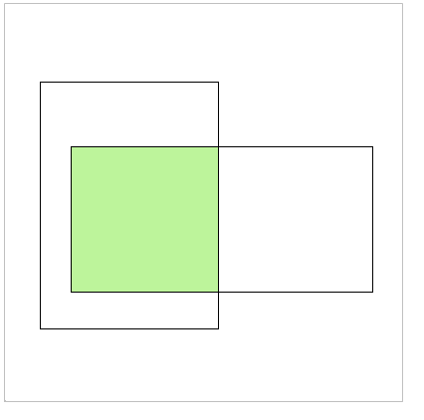 | When combining multiple WORK_AREA_EXCL, the allowed area is limited to the intersection of all elements.  - Green area shows allowed positions  Hint: Robot can’t move at all when the WORK_AREA_EXCL,  are not overlapping at all.
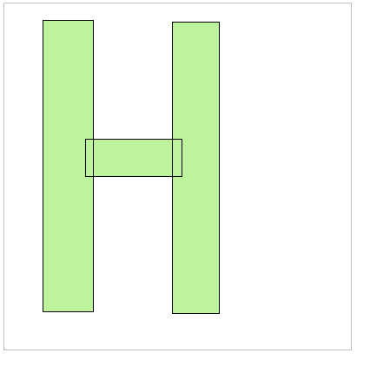 | When combining several WORK_AREA_INC, the allowed range is extended to the sum of all elements.  e.g. To create an “H” overlap 3 zones, as shown in picture.  - Green area shows allowed positions
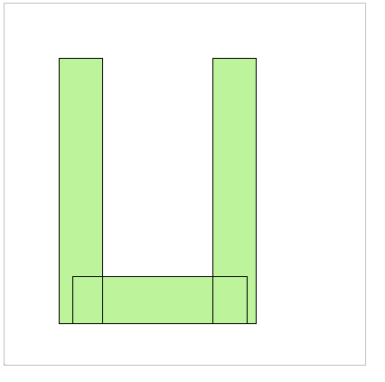 | When combining several SAFE_AREA, the allowed range is extended to the sum of all elements.  e.g. To create an “U” overlap 3 zones, as shown in picture.  - Green area shows allowed positions

Usage of safe areas
As described above, safe areas can be combined. To keep the following graphics clear and easy, no combined safety zones are used.
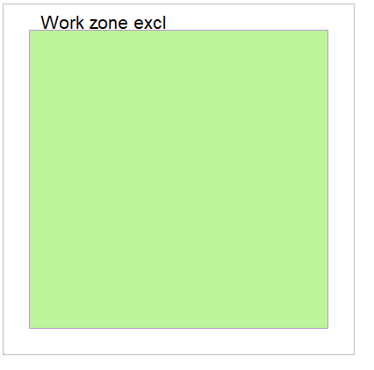 | WORK_AREA_EXCL  - Defines max. work zone (travel range) of robot  - Green area shows allowed positions
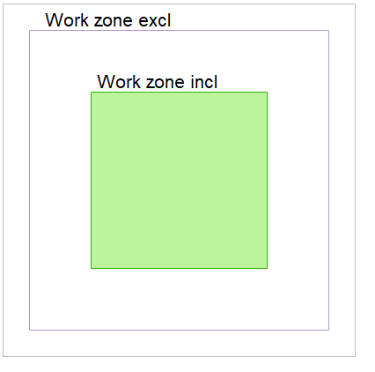 | WORK_AREA_EXCL and WORK_AREA_INCL  - As soon as a WORK_AREA_INCL exits the allowed target positions are reduced to the size of WORK_AREA_INCL  - Green area shows allowed positions
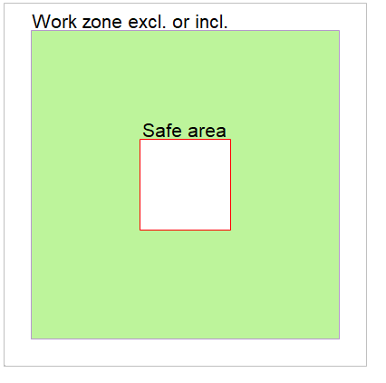 | WORK_AREA_EXCL or WORK_AREA_INCL with SAFE_AREA  - WORK_AREA_* defines max. travel range of robot  - It’s never allowed to move into SAFE_AREA  - Green area shows allowed positions
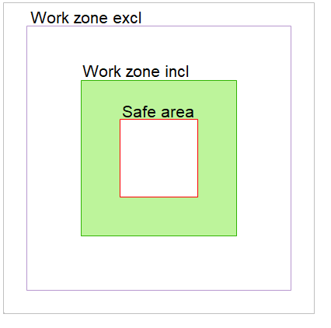 | WORK_AREA_ECCL and WORK_AREA_INCL with SAFE_AREA  - As soon as a WORK_AREA_INCL exists the allowed target positions are reduced to the size of WORK_AREA_INCL  - It’s never allowed to move into SAFE_AREA  - Green area shows allowed positions
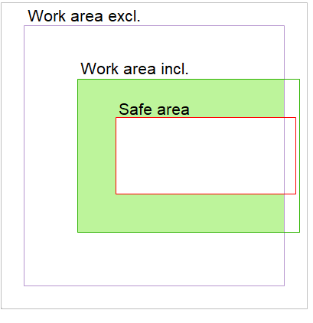 | WORK_AREA_ECCL and WORK_AREA_INCL with SAFE_AREA  - As soon as a WORK_AREA_INCL exists the allowed target positions are reduced to the size of WORK_AREA_INCL  - It’s never allowed to move into SAFE_AREA  - Green area shows allowed positions  - WORK_AREA_INCL and SAFE_AREA outside of WORK_AREA_ECCL are ignored

Define safe areas
The safe areas can be defined in ctrlX web visu. Motion>Kinematcs>Areas. The attached PLC example program contains FB’s to read and write a safe area via data layer.
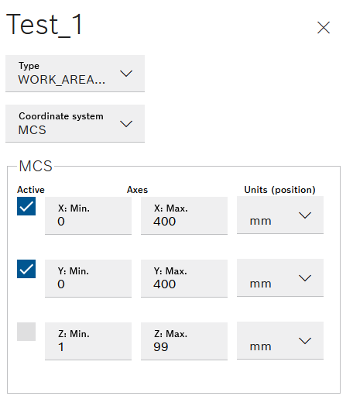 | 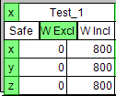  The selection of the coordinate system is not integrated in the test visualization of the PLC program, but in the PLC Function Blocks.
ctrlX web visualization | PLC test program visualization

Activate a safe area
A safe area must be activated, before it is used for the collision check.

PLC:
CXA_Motion.ML_KinSafeAreaP (see example PLC program)

Data Layer
/motion/kin/<kin-name>/cmd/opt-safe-area.
Click “+ Create” and enter string
{
"permType":"PermOn",
"safeArea": "Test_1"
}
- permType supported values: “PermOn” and “PermOff”
- safeArea: Name of the safe area to switch. In example Test_1 is used.
- <kin-name> is the placeholder for kinematic name in the data layer node

Useful Data layer nodes
<kin-name> is the placeholder for kinematic name in the data layer nodes below.

motion/kin/<kin-name>/state/diag-info/diag-descr
Actual diagnosis description. E.g. excl. working area: Test_2
Meaning: Target position is outside of working area Test_2

motion/kin/<kin-name>/state/diag-info/first-diag-descr
Example 1: (Move command)
Safe zone: Test_4
Meaning: Target position is inside of safe area Test_4
Example 2: (Jog command)
Violates safe zone Test_4
Meaning: Could not jog, current robot position is inside of Test_4.
Hint: The text remains until it is replaced by another one. However, there is currently no flag that indicates whether the error text is still valid. You must disable the safe area to jog out of it.

motion/kin/<kin-name>/state/diag/cmd-opt-preselected
“;” separated list with preselected motion options
Example: blending(D1=5.000000,D2=5.000000); safeZones(Machine_1,Machine_2,Machine_Closed)

motion/kin/<kin-name>/state/diag/cmd-opt-active
Same format as cmd-opt-preselected. Motion options of actual running motion commands.

PLC Example program
The example program supports you to get familiar with the safe areas.
Features of the example program
- Define safe areas (range of x,y,z and safe area type)
- 2D display of safe areas (X,Y) with the robot position
- 1D display of 3rd coordinate (Z) with the robot position
- Type specific colors for active safe areas
(SAFE_AREA=red, WORK_ZONE_EXCL=blue, WORK_ZONE_INCL=green)
- FB’s to read (SafeAreaRead) and Write (SafeAreaWrite) safe area data
- Set operating mode of kinematic
- Jog kinematic
- Move kinematic to absolute point
In ctrlX web visu:
- Define axes “X”,”Y”,”Z” (Pos min=0, Pos max=800)
- In ctrlX web visu: Define kinematic with name “Robot”. Assign axes: “X”,”Y”,”Z”
In PLC visu:
Yellow marked items, are editable.

1. Define safe zone (x,y,z and type)
2. Show/hide "safe zones" to detect it's location (button “x”)
3. Press "Write safeArea" to enable jogging
4. Ensure that IMC is in IMC_MODE_STATUS_RUN
5. If any error is active clear it
6. In "Kinematic control" select "Setup (Jog)"
7. Use frame "Jog Kinematic" to jog axis to limits of safe areas...
8. In frame "Safe zones" enable/disable any safe areas and jog axis
