Template Additive Manufacturing

AppBasicProjectAM_04V04
MTX Basic Project Additive Manufacturing
For IndraWorks 15V18

Content
1. Requirements 4
1.1. Hardware 4
1.2 Software 5
2. Installing of Basic Project „AppBasicProjectAM_04V04” 5
3. Fill in the control`s IP-address to get access to the control. 7
4. Activate the Emulation 9
5. Switch the control online 10
6. Restore the Control Data 11
7. Activate the Operation Desktop 13
8. Structure of the Template 16
9. Structure of the PLC Program 17
10. Important Definitions for Axes and Channels 18
11. Important Definitions for Visualizations and our Message System 19
12. Global Variables 19
13. Structure of the individual PLC programs 20
14. Function description factor control 3D printing 22
15. Enable the changes 24
16. Testing the function 25
17. Commission system axis coupling 25
18. Changes in the NC user program 25
19. Drive configuration 26
20. Axis group (Gantry) 27
20.3. Commissioning 29
20.5. PLC plug-in 31
20.6. Special Screen 32
20.7 Temperature Controller 41
20.7.1 Example project 45
20.7.2 Temperature Controller Screen 49
20.7.3 Temperature Overview Screen 53
20.7.4 Temperature Overview Control in the NC-Screen 54
20.8 NC Simulation 55

Requirements

Hardware
- Control "IndraControl MTX-XM42, with suitably set IP address
- Control is connected to the programming device via Ethernet and USB (XF31).

IndraControl XM 42
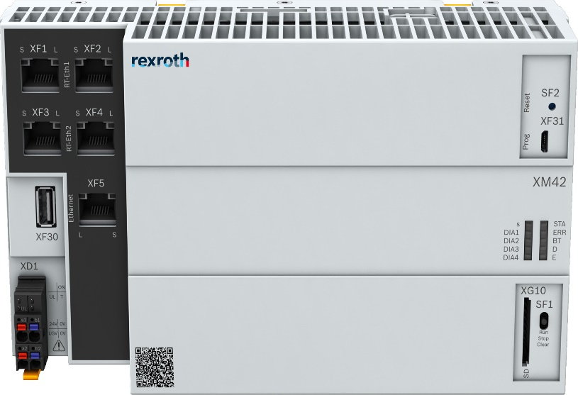
- In the delivery state of the XM42 an initial firmware is installed.
- There is no system firmware installed.
- The MTX system firmware must be loaded via Indra Works Engineering.
- If no system firmware is available, the control runs automatically into the initial mode after switching on => display initial mode per status LEDs
- If a system firmware is available, the controller automatically goes up to MTX system mode after switching on.
=> Display of MTX mode by status LEDs

Find more information in the Commissioning Manual MTX15VRS R911393281.
To run the template, a hardware is not necessary because you can use our emulation.
It is only our Engineering Software which is essential. With this software you have the possibility to test the template with our emulation.

1.2 Software
On the engineering computer the installed development environment "IndraWorks for MTX" for example “IndraWorks Suite” is needed.
You need the version MTX15V12 or higher for this template.

In addition, _the Example project “AppBasicProjectAM_04V1” is needed, this is provided as an IndraWorks archive (zip file)

Installing of Basic Project „AppBasicProjectAM_04V04”

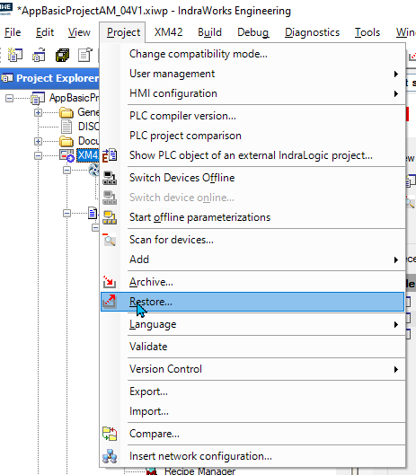

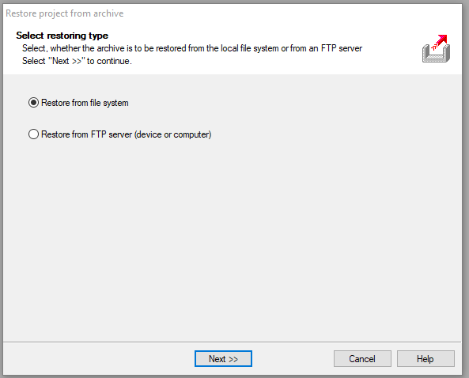
- Select the menu “Restore from Filesystem”

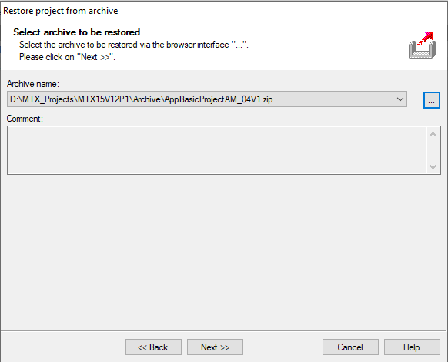
- Select the Project from your Storage Place.

Fill in the control`s IP-address to get access to the control.
Properties\ Configure\ Configuration\ IP-Address
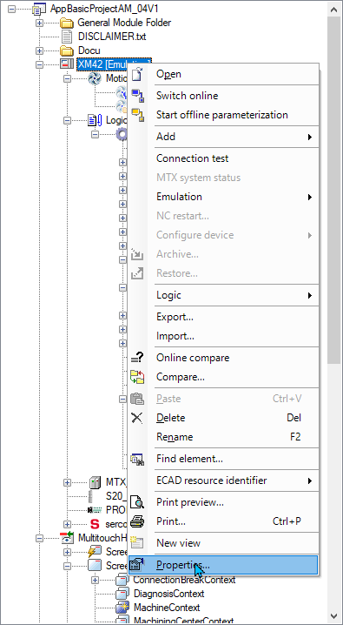

2.1. Fill in the control IP- address XM42
- To connect your engineering PC to real control. Operate the control via IP-Address
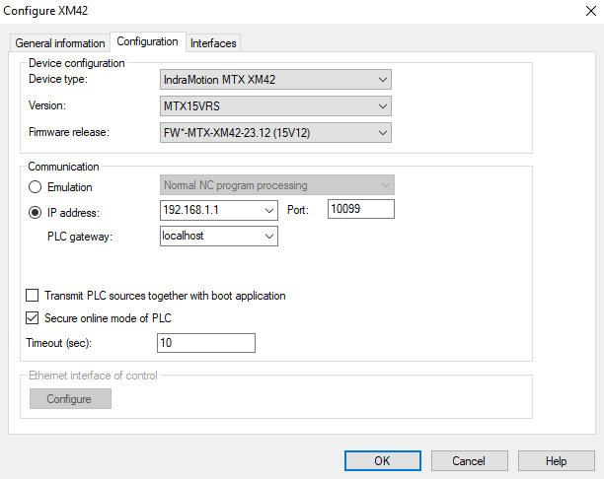
- Or select the Emulation to work without a real control
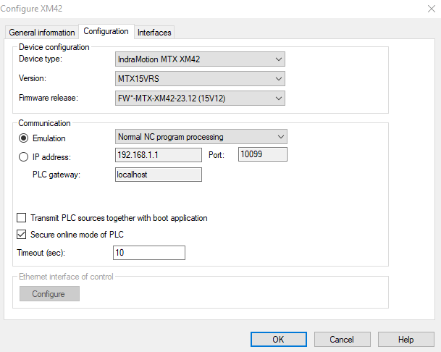

Activate the Emulation

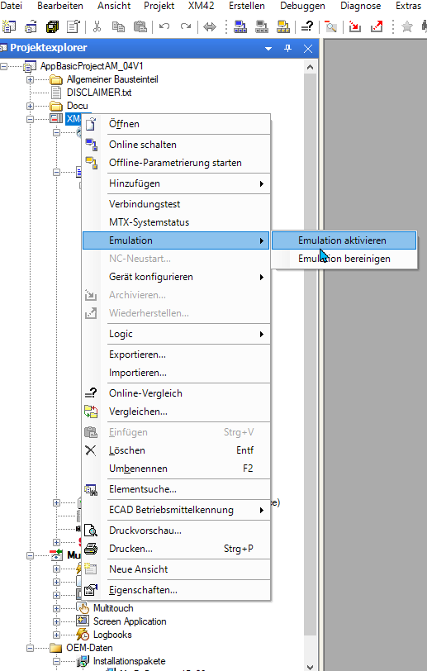

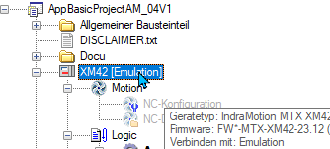
Now the Emulation is active.
- Switch the control online
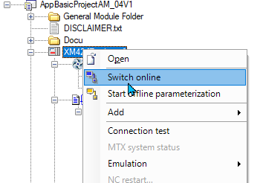

Restore the Control Data

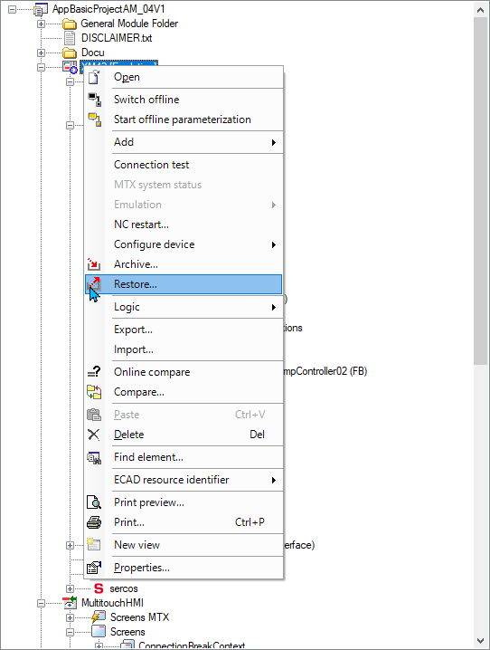
- Right click on the control
- Select the menu item “Restore” and confirm

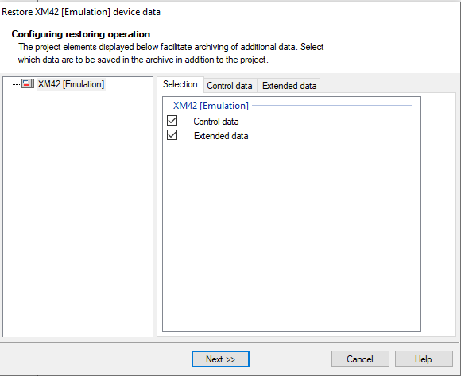
- Select Control Data (load the machine data for example axes, channel, …)
- Select also Extended data to (load NC Programs, SD- variable lists to the mnt- folder)

Activate the Operation Desktop

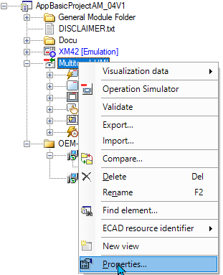

- Right click on the visualization device
- Select the menu “Properties”
- If you run the HMI on the engineering laptop select localhost otherwise the correct IP- address of the visualization PC must be included

  - Properties from the HMI
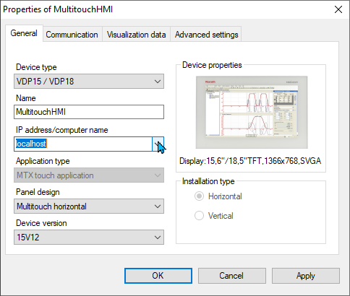
- Select localhost to run the app on the engineering Laptop

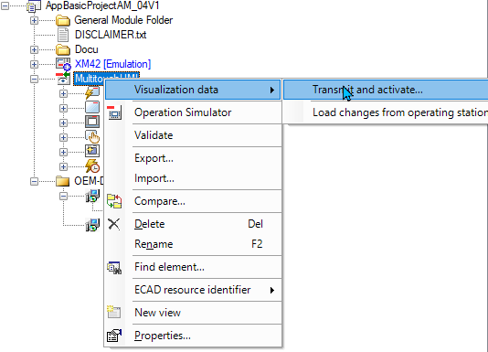
- Now transmit the data to your visualization device.
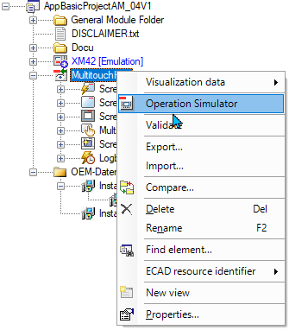
- After transmitting the data you can start the HMI. Go to Operation Simulator and confirm
- The HMI runs in an extra window and simulate the real machine interface.

Structure of the Template
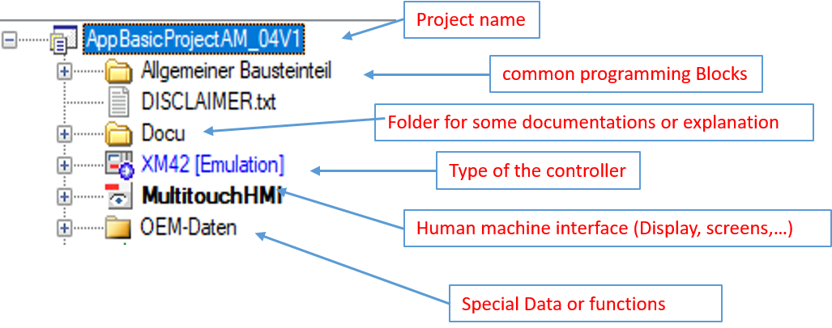
8.1 More details of the structure
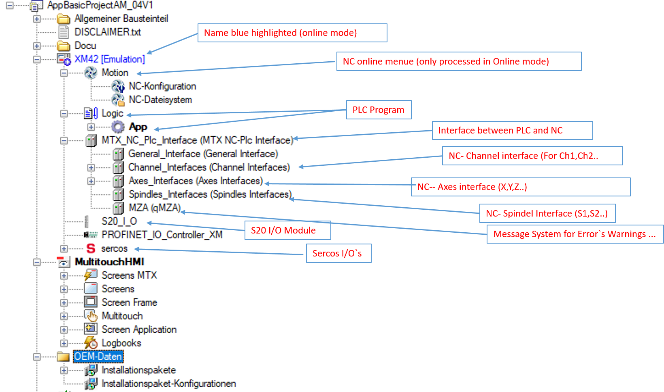

Structure of the PLC Program

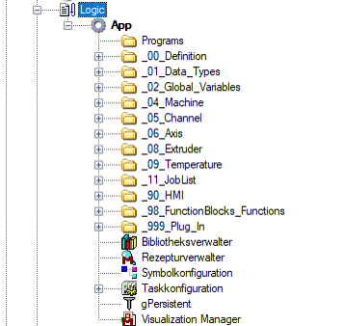

Important Definitions for Axes and Channels
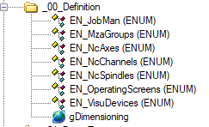
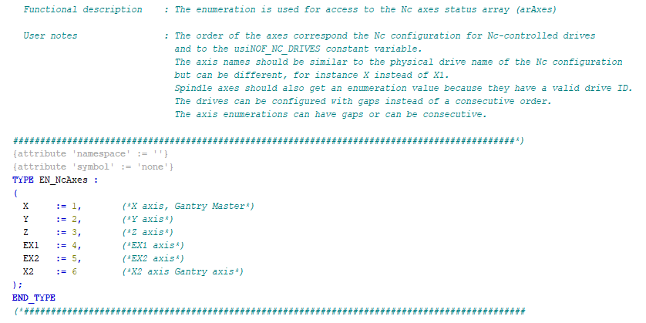
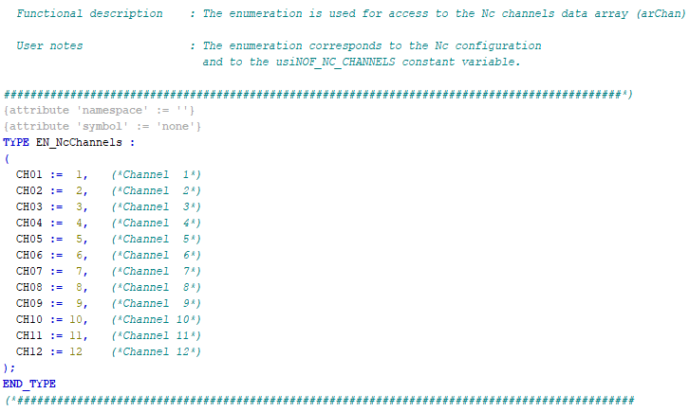

Important Definitions for Visualizations and our Message System

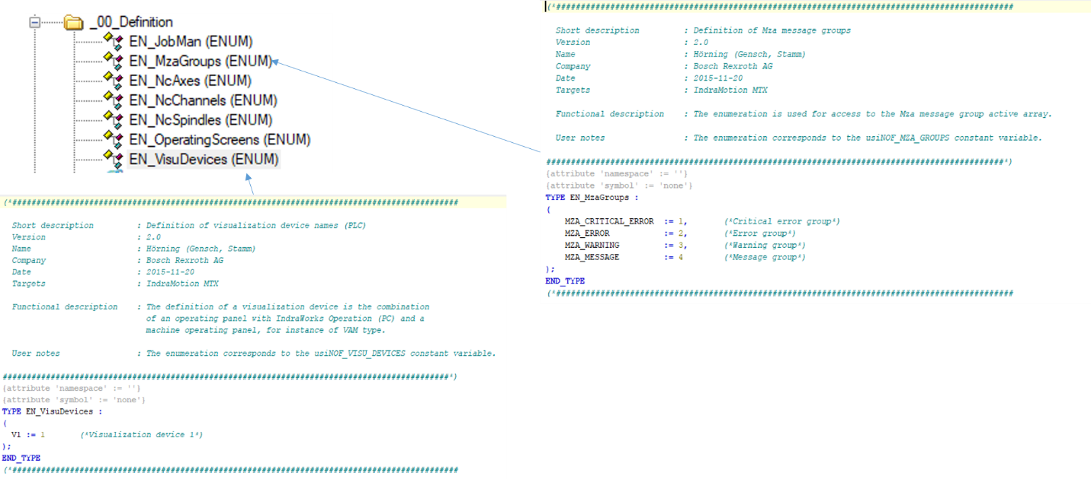

Global Variables

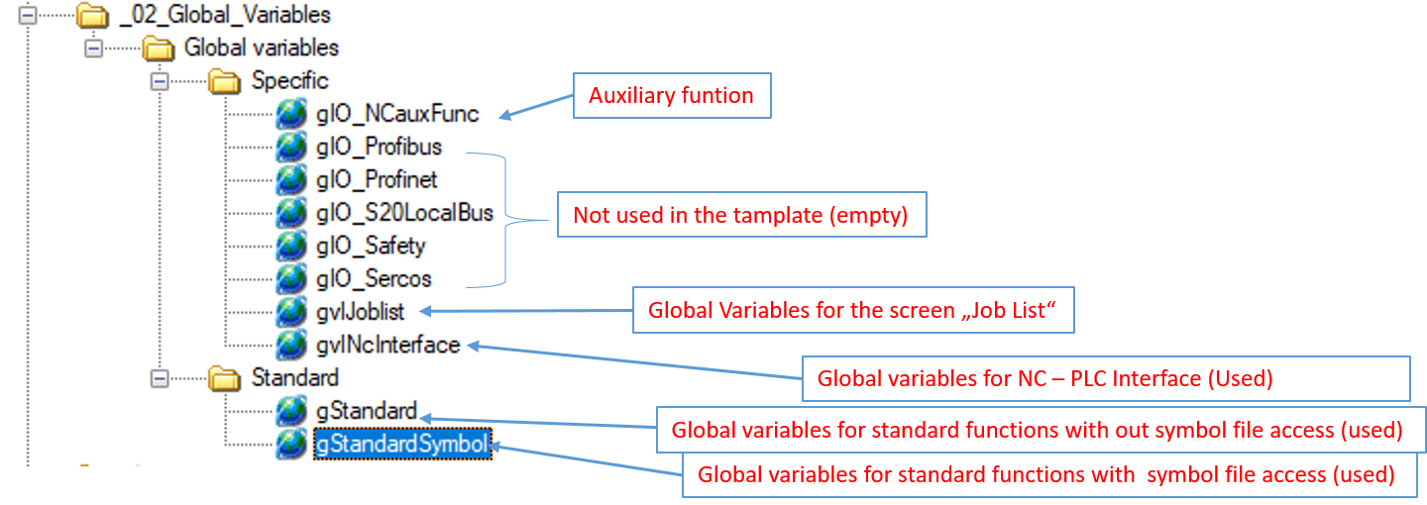

Structure of the individual PLC programs
  - Main Program
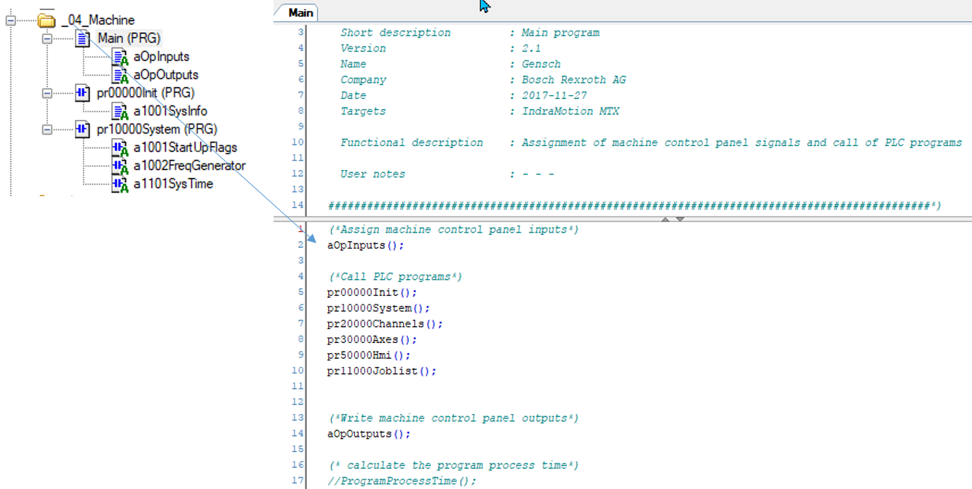

- The Main program call all other PLC- programs. This Main program is also running in the PLC Task
  - Channel Program
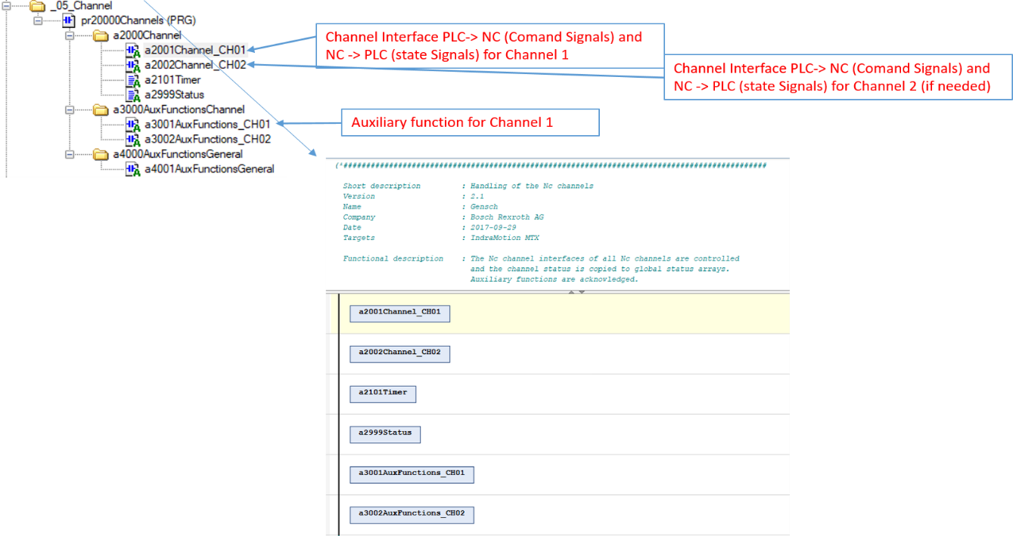

  - Axes Program

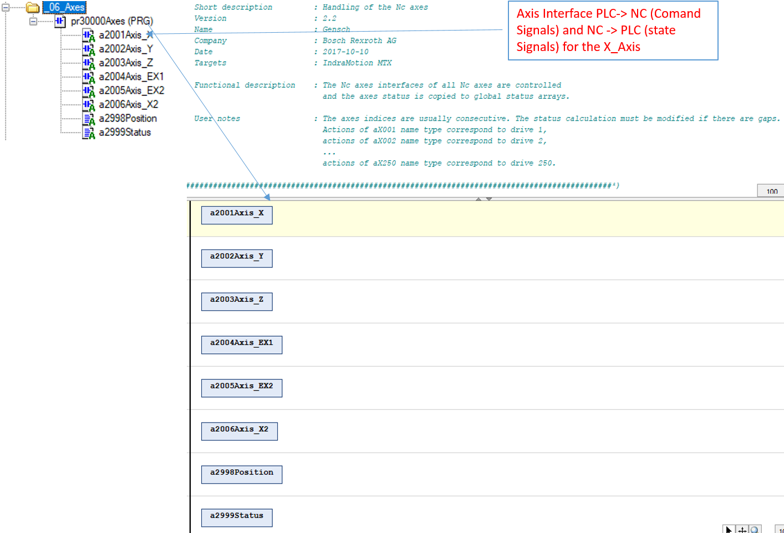

  - Extruder Program

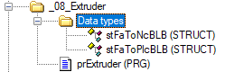
The Extruder Program is a special program to control the Extruder Axes. This program realizes a factor control of this axis.

Function description factor control 3D printing
At the 3D printing it often happens that the extruder axis should not exactly follow the value specified by the program. This means that the amount applied is not equal to the expected result.
Here, with the MTX, we have a solution for how the customer can give a factor to the target values of the extruder axis. Thus, an additional control (additive to the NC program), can be created.
Since the extruder axis is normally programmed in the NC program for each line, it is not easy to get a change in the thickness of the used printing material.
In the MTX there is the possibility to influence the programmed distance of the extruder depending on certain parameters.
For example, the faster the NC drives, the greater the output.
For this control 2 functions of the MTX are used.
  - System Axis Coupling
To achieve this, the function of the system axis coupling is used.
For this purpose, the axis is coupled to itself via a coupling factor. Since the coupling only takes e ffect after the interpolator, it is thus possible to directly influence the target values of the NC.
  - Fast Action Runtime
The FA task of the MTX is used to provide or calculate the values as quickly as possible and NC cycle time synchronously. This is a special task of the PLC of the cycle time synchronous to the NC is processed. Here, the machine manufacturer/ end customer can easily bring his know- how in the form of PLC logic and calculations.
Two variable lists are created which are used in the system axis coupling.
Input Variables:
iStateToPlc: Input of the PLC for the control switches on the FA calculation and the system linkage at
the moment with 0 -> 1.
iFactorToPLC: Input of the PLC of type REAL here can be passed via the PLC or the NC program a factor
for the FA task. No function at the moment.
iAxisX., IAxis8., iPathVeloCH1: These input variables are used to calculate the functions to be realized in
Fast Action.

Output Variables:
qStateToNC: Output of the PLC for reporting status information to the NC. At the moment no function
qFactorNC1,qFactorNC2: output of the PLC type REAL. Here the calculated values can be returned to the
NC. Weighting factor for the system coupling of extruder axis.
qFA_FeedHold: Input lock from FA task 1= channel 1

  - How it works
With the NC-program “FA_Init_xxx.npg” the FA task is switched on.
Now the calculation can be switched on or off via the variable "iStateToPlc".
The NC program “SACACT” activates the coupling in the main program. The coupling condition here is "SD.iStateToPlc = 1 ? SD.qFactorNc1 * AC "
Explanation of the coupling condition
If the variable SD.iStateToPlc is equal to 1 then the coupling condition factor SD.qFactorNc1 * follow-axis interpolation value AC(Set position of the axis from the NC program).If the variable SD.iStateToPlc is not equal to 1 then only the target position.
With active coupling, the coupled axis move the position in the NC program * the factor. Thus, the machine operator can influence the desired quantity in the NC program or via the HMI, or the FA task can calculate the quantity.

  - NC Part
NC programs
The function requires 4 subroutines.
- FA_Init_FacCon.npg
The program FA_Init_FacCon.npg is required to initialize the Fast Action data. Here the system data of the FA task described, and the FA task started.
- SACACT
The SACACT program used to apply and activate the coupling for the extruder.
- SACOFF
The "SACOFF" program used to clear the coupling for the extruder.

SACVALID
- The program "SACVALID" called only by the program SACACT and is an auxiliary program for diagnosing coupling errors during initialization.
- Variable list STSFacCon.var. The variable list STSFacCon.var used to diagnose the function.
Note
All 4 programs and the variable list must be copied to a folder known in the search path of the NC.
For example, usr/mtb" or usr/user" or directly in the main path c:/mnt.

Systemdata
- For the FA task to be set up correctly with the function, the system needs some new system data.
SD.SysFA
- The Fast Action task configured via system data. By default, this system data is not active. To activate the system data structure, we proceed as follows. First go to the folder feprom \schemas in the file system of the NC.
Copy the file “sdfa.xsd_" to the usrfep “schemas" folder. Then rename the file to “sdfa.xsd". Next, take the file “SDDeffa.xml_" from the folder “feprom " and copy it to the folder “usrfep”. Again, remove the underscore from the name and rename it to "SDDeffa.xml".
SDDefFaSTS
- The factor regulation requires different variables to control the function.
These defined in the file "SDDefFaSTS.xml". Please copy the file from the list to the folder "feprom".

Enable the changes
In order to activate the extended system data, a NC restart must now be performed. After the NC is up again, the PLC changes can now be transferred with debug login. Then restart the PLC program via Debug Start. The data is now ready.
The programs are located in the folder mnt\FA_Task_Extruder.
Note
The steps already done in the Template. The data saved in the Tar- File.

Testing the function
Commission the FA task
To activate the FA task now, the FA still needs the configured system data. These can be entered with the imported subprogram. Simply select the program "FA_Init_FacCon.npg" and start it. Now the state of the FA can be checked using the "STSFacCon.var" variable list.
The variable "SD.qStateToNc" should be used in bit 12 toggles, which means that the value always changes by 4096. The FA is now operational.

Commission system axis coupling
The system axis coupling used here to give the factor calculated in the Fast Action to the extruder axis. To activate the coupling, the SACACT program must integrated into the printing process. To do this, activate the program before the actual printing process. In the "Channel Init" program, the coupling can simply be switched off again via the “SACOFF” cycle.

Changes in the NC user program
The MTX does not fully support the Modulo function. To avoid problems, the following things should be considered. No movement of greater modulo range may be programmed. The addition of the individual sentences can also lead to an overshoot of the range.
To do this simply zero setting in every set before programming the extruder axis.
For example:
From G1 X1468.780 Y412.014 E1=IC49.3392" then becomes "G1 X1468.780 Y412.014 LMZ(E1) E1=IC49.3392".
This is normally no problem as the programs is automatically generated anyway and the programmer can specify the syntax for the extruder axis.

Drive configuration
The axis must be linearly weighted. For axes that are set up as linear modulo axes, the modulo value should always be greater than the longest distance programmed in the set of the extruder.

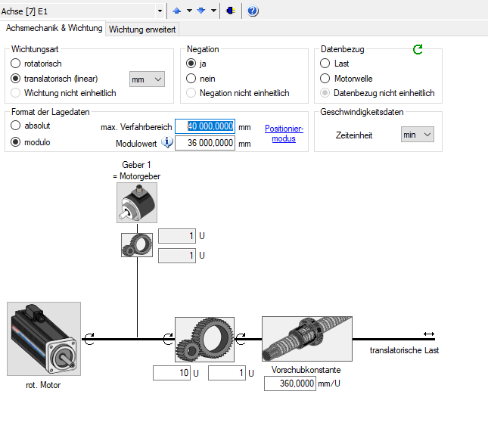
Example of the Linear Modulo weighting setting.

Axis group (Gantry)
  - Overview on Gantry
An axis group of two or more axes that follow one common preset is referred to as a Gantry. In general, the axis group is not mechanically connected. Each axis has its own controller and motor. When controlling the axis group, the positions of the axes as well as the axial limits (position, velocity, acceleration and torque) are compared against each other and controlled according to the
weakest axis.

A Gantry axis group has to meet the following conditions:
- The measuring system has to be identical on all axes.
- All axes have identical axis parameters
The Gantry axis group works for the following weighting methods:
- Linear absolute
- Linear modulo
- Rotary endless
- Rotary modulo

  - Control behavior
The control behavior of a Gantry axis group is specified in the following. The reasons for position deviations of individual axes as well as the control behavior resulting thereof are discussed.

Note
For a detailed description of the Gantry function, see the documentation "Rexroth IndraMotion MTX Functional Description 15VRS - Extension" (see chapter 1.4 "Required and supplementing
documentation MTX" on page 2)

During the movement of the axes, the NC automatically compensates the deviations
of the axis position to the end of the NC block.

Requirements
The following requirements have to be fulfilled for the operation of a Gantry
axis group:
- All axes belonging to the group were commissioned correctly.
- All axes belonging to the group are referenced.
- No offset is set for the target position.
Deviations of the axis position during processing can have the following reasons:
- a unilateral blockage
- an uneven load of the individual axes
During axial standstill or braking, a deviation of the axis position may occur
for the following reasons:
- Different braking response during delay
- A value difference could not be compensated during the motion path as
the drives were switched off.
- The axes have shifted each other when switched off.
- Open loop axes drifted away.

Starting behavior: When the axes are switched on, the NC specifies identical target values for all axes of
the Gantry axis group. If the resulting position leap of individual axes is too big, an
error (F2037: excessive command value specification or
F2028: excessive control deviation) is triggered in the drive. If the deviation
remains, it is applied and considered as static offset during later movements
by the NC. This occurs under the following conditions:
- For drives with absolute encoders at control startup if the axis is referenced
- For drives with incremental encoders when referencing
- When driving to a reference point with mechanical switch
Compensation motion: A command value offset can be compensated during axis interpolation. An
asynchronous axis movement of one or more axes of the axis group compensates
an actual value offset.

Commissioning
This chapter describes the commissioning of the Gantry axis group. The conditions, parameterization and the diagnostic options are described.

Before commissioning the Gantry axis group, the drives in the Sercos bus have to be available. The axis names and the Sercos addresses have to be entered beforehand.

    - . Activating settings for the axis coupling

Open the NC configuration by double-clicking on XM42 ▶ Motion ▶ NC configuration. Select the first entry "Selection of Optional Parameters (SUP)" on the right-hand side of the IndraWorks window. Activate the entry "Electronic Couplings (COUP)" in the selection list.

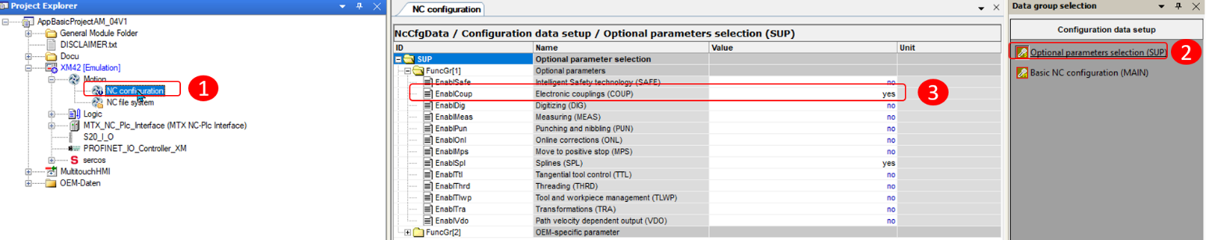
Picture 20-3: Activating settings for the axis coupling

    - Parameterization of the Gantry axis group
Open the NC configuration by double-clicking on XM42 ▶ Motion ▶ NC configuration. Select the first entry "Electronic Couplings (COUP)" on the right-hand side of the IndraWorks window (①).
Adjust the settings for the axes (②) to be operated in the Gantry axis group according to Pic. 20-4 "Parameterizing Gantry" on page 33.
The upper axis is parameterized as the group master. Select the same "axle group index" (③) for all axes in the group. Change the "Maximum lag distance" according to the machine (④). If the lag distance is larger than the specified value, the NC generates an error message.
Parameterize the entry "Upper limit for Gantry command value offset" (⑥). This value determines the maximum deviation of the command values between the master and the slave axis. This value can only be set if the entry "Balanced Gantry command value offset" is displayed on the
selection "Max. value from "Maximum lag distance"" (⑤).

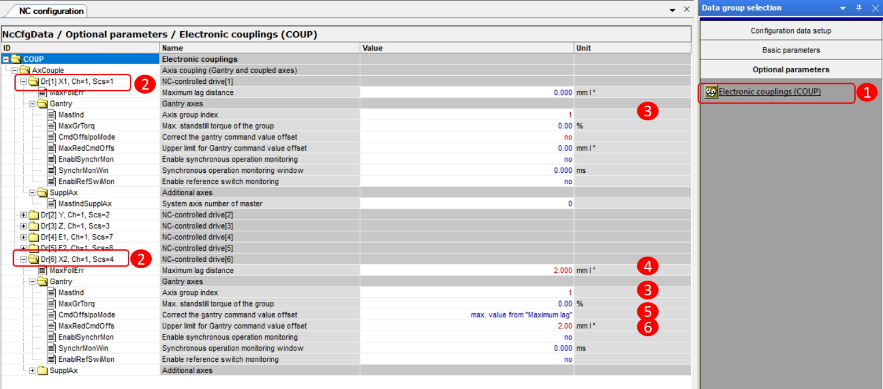
Picture 20-4: Parameterizing Gantry

  - Complete parameterization
Close the window "NC configuration" to complete the parameterization.
IndraWorks asks whether the NC should be restarted. This has to be
done in order to activate the new parameterization.

PLC plug-in
In addition to the NC-controlled axis Gantry function, there is another PLC controlled auxiliary function which compensates the position offset of the axes at machine start. This function is executed as a plug-in in the AM project.

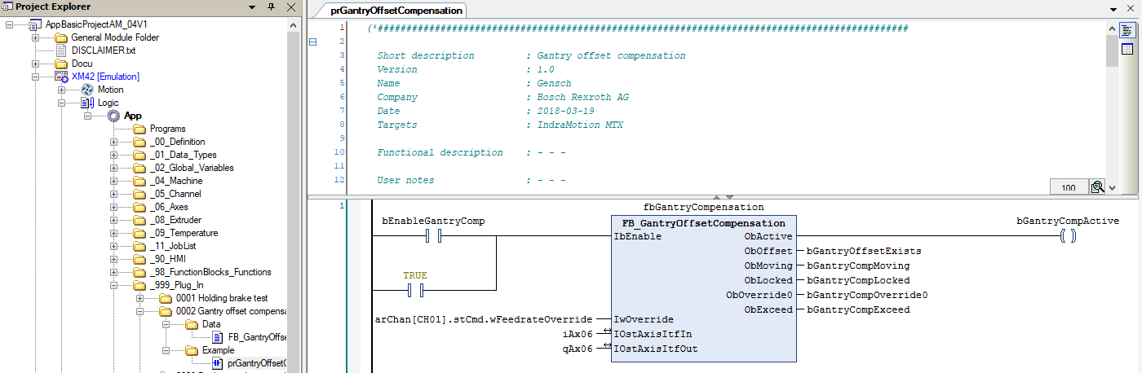

The plug-in can be integrated by calling in the PLC main program "Main".
Requirements In order to use the plug-in, the following requirements have to be fulfilled:
- In the case of absolute encoders, a master and at least one slave axis must exist
- In the case of an incremental measuring system with a relevant position measurement, there has to be one reference point for all axes of the Gantry axis group.
- All axes have to be enabled and referenced
- The difference between the commanded and the actual position is smaller than the maximum permissible deviation set in the parameterization (cf. chapter 20.3 "Commissioning" on page 32)
- The upper limit for the deviation of the commanded positions is not exceeded or the monitoring is switched off (cf. chapter 20.3 "Commissioning" on page 33)

Special Screen
    - Screen Job Management

In our template there is a special screen inserted. This screen is named "Job List". The follow items we are needed for the screen.

- OEM Daten
Add and transfer installation package MtxFisBrowser_15v06.msi
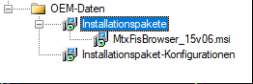

- PLC
Global Variable List:

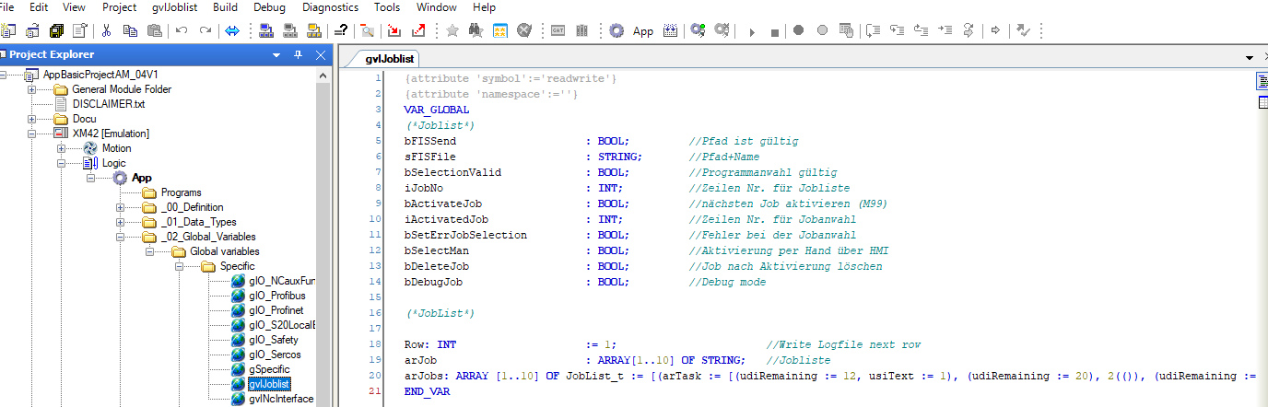

Program prJobList

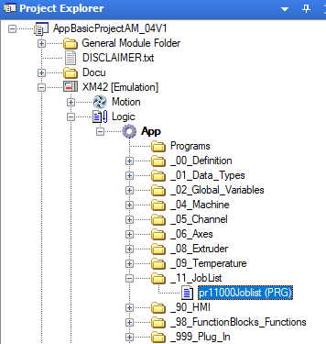
- HMI
  - Winstudio
Driver sheet 10 "Job list"
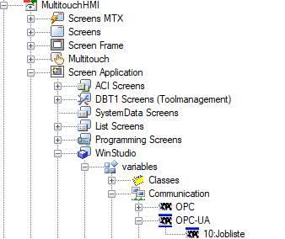

User variables
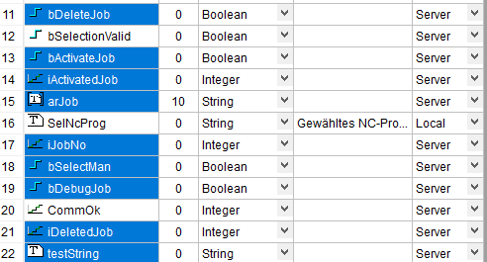

The image joblist_and FIS_Browser
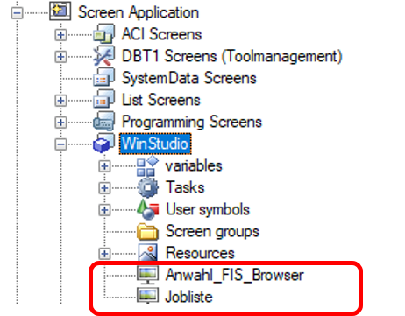
Load the fis Browser
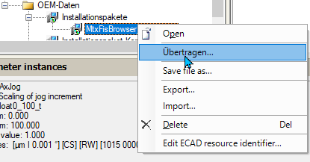
- Right click on “MtxFisBrowser” then select the second item
“(Übertragen”(Transfer).

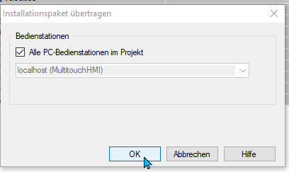
- Select ok

    - Call the Picture in the HMI

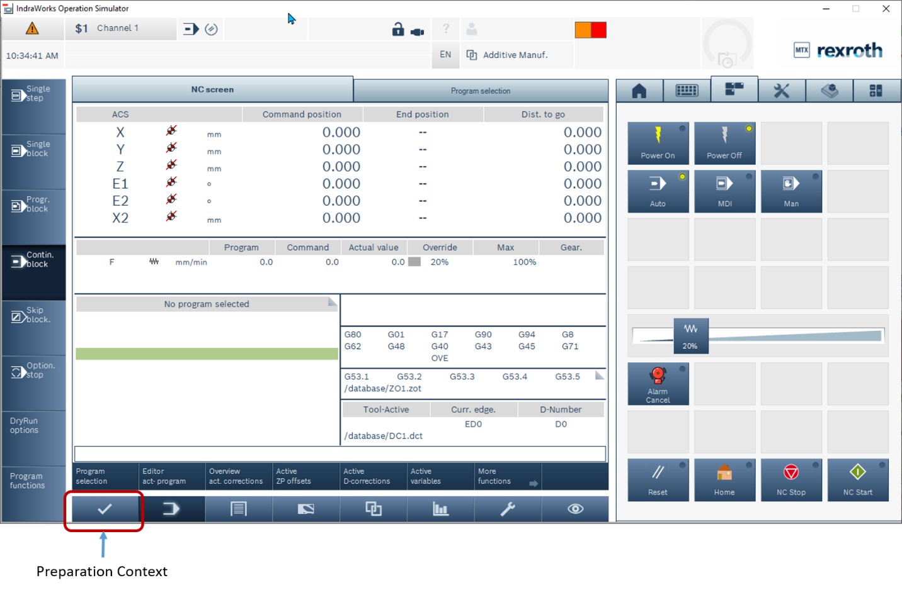
Picture 20-5: Call Preparation Context

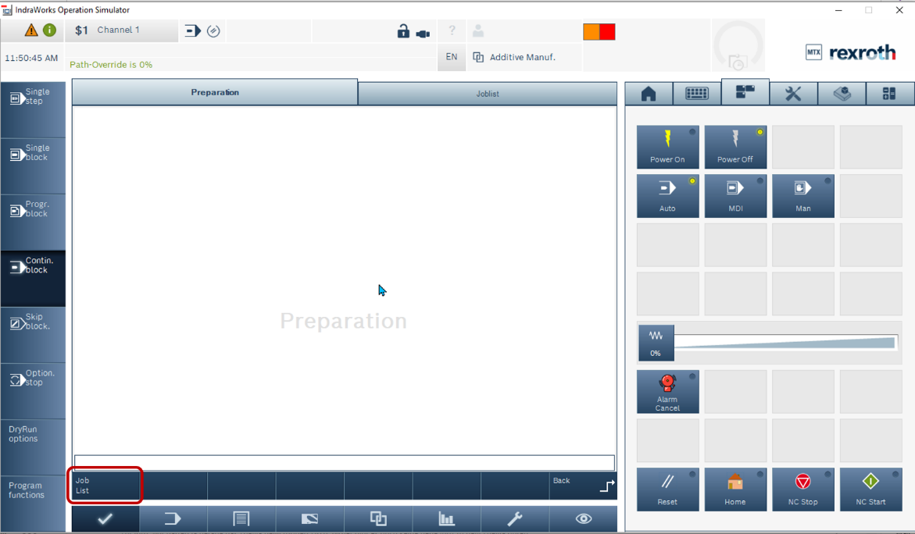
Picture 20-5: Call the screen Job List
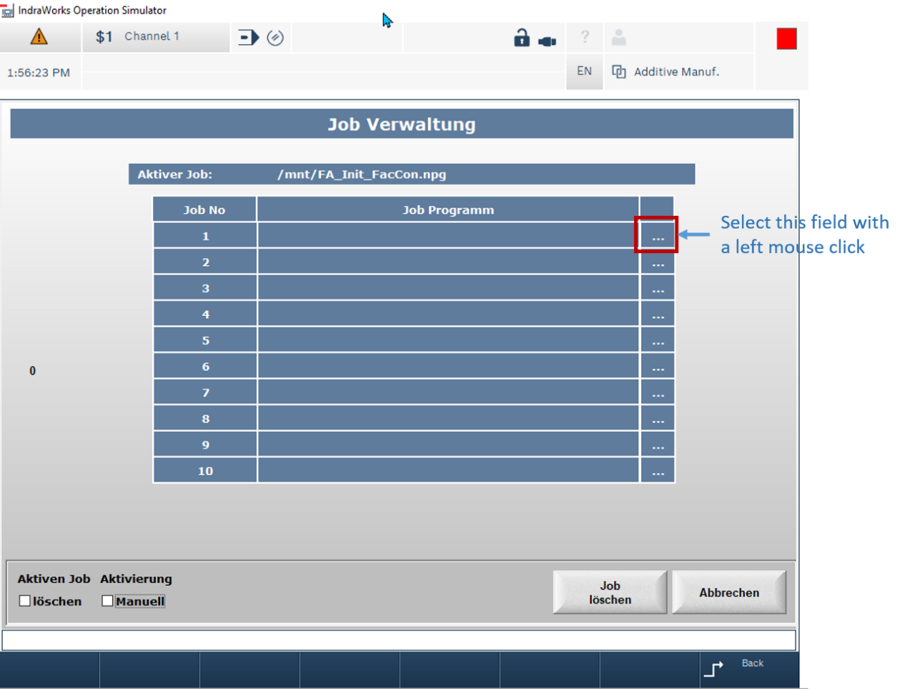
Picture 20-6: Insert a Job

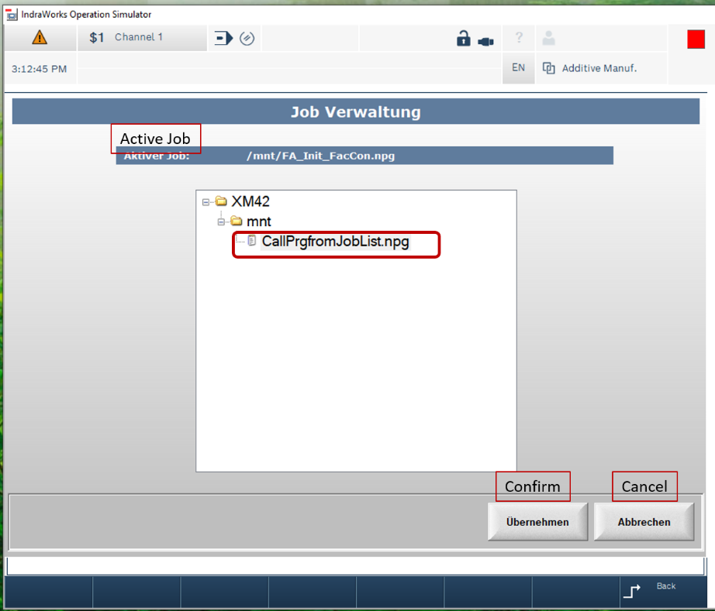
Picture 20-7: select a Job
After confirming the Job is available in the Job List. See Picture 20-8.
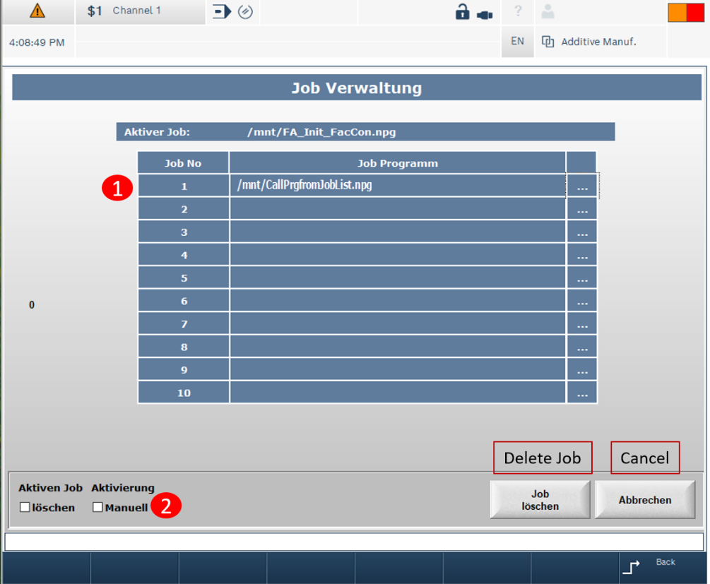
Picture 20-8: activate a Job
Click with the left mouse button in the field 1, where the name of the Job is show.
1
Click in the small box Manuell (manuel)
2

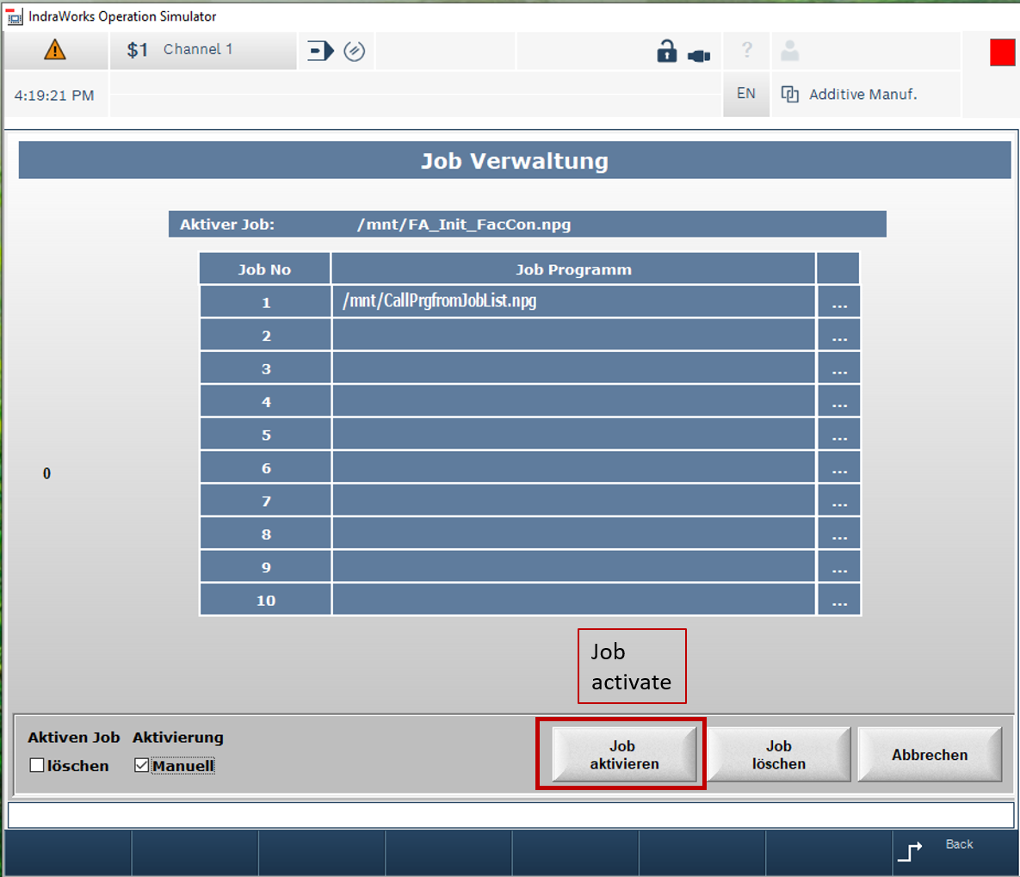
Picture 20-9: activate a Job

- After clicking, a new button “Job activate” appears.
- Now click on this button and the new job is active (see picture: 20-10)

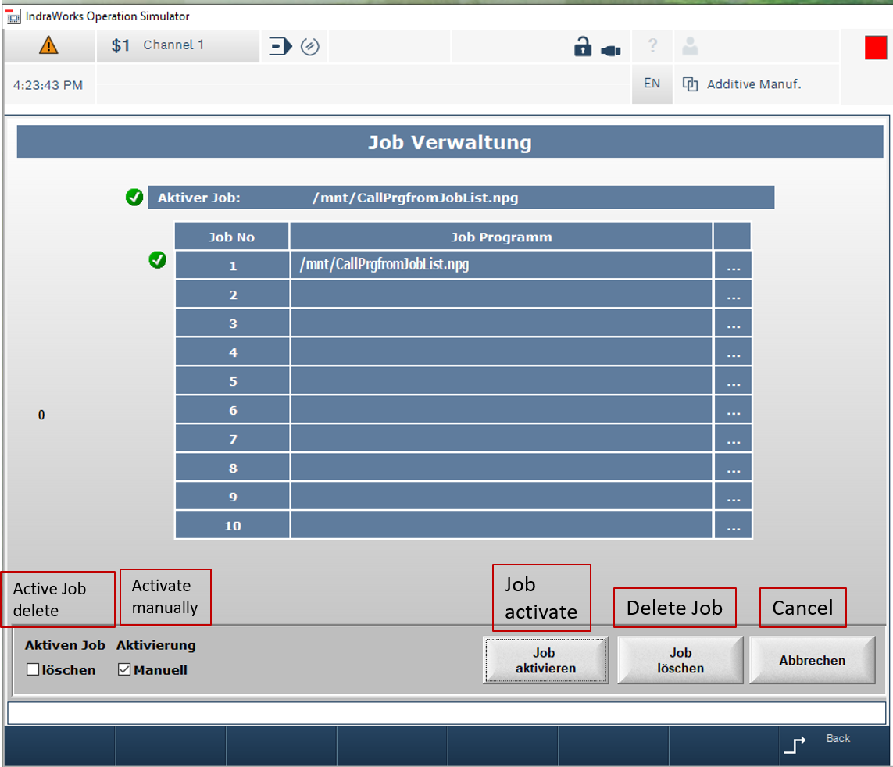
Picture 20-10: activate a Job

- Now the Job is active. You see the new name of the Job in the first row. If you change to NC-screen the program is ready for processing.
- The program preselection is done in the PLC directly.
- To read this name from the Job List in the NC, you must use the NC- program “CallPrgfromJobList.npg”.

    - NC Program for the Job List

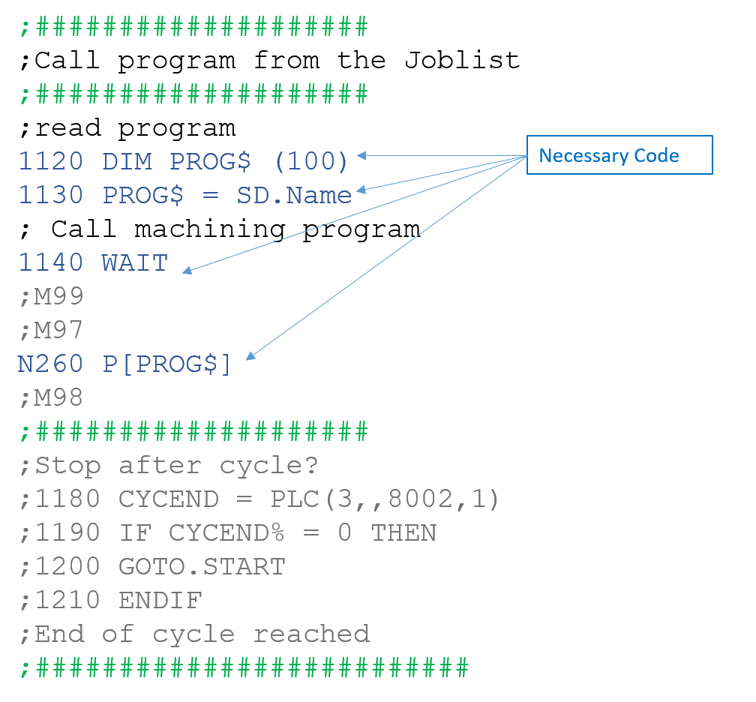
- See in mnt\JobList

20.7 Temperature Controller

In the library “RIL_LoopControl”, there are two function blocks for temperature
control. The advantages of “IL_TempControlType02” are:
- Shorter identification period (StartAutoTune)
- Changed controller parameterization (preset)
- Changed fine controller adjustment (DampingFactor)
- Input/output of the controlled system parameters (ModelParam)
- Individual controller design (ControlMode)
Because of these advantages, the function block “IL_TempControlType02”
should be preferred. A quick introduction should be given in the following. This
document should only support you to run the basic functionality of the function
block in a quick way. The description of the functionality or detailed information,
you can find in the documentation Basic Libraries, IndraLogic 2G (DOKIL*
2G*-BASLIB**V14-LI04-EN-P, R911343920).
To use the basic functionality of the function block you must provide a temperature setpoint (Input Setpoint), the actual temperature (Input Feedback), which could be provided via Inline/s20 module or e.g. a field bus connection, and a structure for the controller Parameter (In/Output ContrParam) and the
model/controlled system Parameter (In/Output ModelParam).

The internal controller type is per default parameterized as a PI-controller (structure element ExtentedSettings. ControlType=CONTROL_TYPE_PI), which requires no modification for standard applications.
(The controller could also parameterized as a PID-controller via structure element Extented Settings. ControlType=CONTROL_TYPE_PID. To use the controller e.g. as purely P-controller, you must set the other parts to zero).
The control value can either be retrieved at the analog output (ControlValue-Analog) or at the digital output (ControlValuePWM, pulse width-modulated).

For a quick run of the basic functionality, you must not modify the other inputs Limits, ExtendedSettings, StartUpTime, StartUpTemp, OutputPowerMax, Dampingfactor and SetpointGradient.

When enabling the function block (input Enable) you can either set the internal controller parameter to the values of the structure ContrParam/ModelParam (see Preset below) or you can start the automatic identification, which evaluates the values of the structure ContrParam/ModelParam (see AutoTune below).

With the input Preset (pos. edge) the controller parameter (In/Output ContrParam) and the model/controlled system parameter (In/Output Model- Param) are always set to the internal variables. When the input is set with the input Enable, the parameters are applied as well.

The following behavior is associated with the Preset of the controller and model/controlled system parameter:

- structure element ContrlParam.Kp is not equal to zero
- Temperature control runs with the controller parameter of the structure
ContrParam.
- All controller parameter (ContrlParam.Kp/Ki/Kd) equal zero
- Model/controlled system parameter (ModelParam.Ks/Ts and Contrl-
Param.Tt) are necessary to calculate the controller parameter!
- Temperature control runs with the controller parameter, which are
calculated out of the Model/controlled system parameter (Model-
Param.Ks/Ts and ContrlParam.Tt). These values are also transferred to
the structure ContrlParam.

With the input StartAutoTune (pos. edge) a new automatic identification(self-adjustment) of the controlled system could be started. When the inputis set with the input Enable, the identification is started as well.

There are different control modes (see ControlMode below) available, with which the type of control could be selected, to do the optimization. With the identification in the ControlMode CONTROL_TEMPMODE_OPT_ COMMAND (2) or CONTROL_TEMPMODE_OPT_
DISTURBANCE (3) the function block, determines the controlled system parameter (ModelParam.Ks/Ts) and the controller parameter (ContrlParam.Kp/Ki/Kd/Tt).
The ControlMode CONTROL_TEMPMODE_ONLY_DISTURBANCE (4) uses a special algorithm, so not all model parameters are determined (Model- Param.Ks is missing).

To start the automatic system identification (AutoTune) with every enabling of the function block or restart of the control (MLC/XM) is not essential. If the controlled system is nearly identical and a good identification is found for the system, it is recommended to back up the determined parameter in the retain area.
The structures ContrParam and/or ModelParam, which contain the controller and/or controlled system parameters, can be created as retain variables (VAR RETAIN).

Hint:
There are a few things to consider, when doing an automatic identification. The Value of ContrlParam.Kp must not be equal to zero. Make sure your jump to the nominal value is high enough. The difference between the “Feedback” –value and the “Setpoint” has to be high enough. In addition, the task interval
time has to be set in dependence on actuator and control path.

There are four control modes available, which could be selected via input ControlMode:
- CONTROL_TEMPMODE_MANUAL (1):
Controls the actual controlled system value using the value of input ManContrValue It can be used, if you have an error and do not want to set the control output ControlValueAnalog or ControlValuePWM to zero. To use this mode, you set the ControlMode and you have to enter a value in percent on the input ManContrValue (0-100%). Now the controller is permanently outputting this value.

- CONTROL_TEMPMODE_OPT_COMMAND (2):
Optimizes the command value response of the "Feedback" value to the "Setpoint" value.
With available controlled system parameters (ModelParam.Ks/Ts and ContrlParam.Tt), the controller parameters are recalculated with a switch to ControlMode CONTROL_TEMPMODE_OPT_DISTURBANCE.

- CONTROL_TEMPMODE_OPT_DISTURBANCE (3):
Optimizes the disturbance response of the "Feedback" value to the "Setpoint" value.
With available controlled system parameters (ModelParam.Ks/Ts and
ContrlParam.Tt), the controller parameters are recalculated with a switch
to ControlMode CONTROL_TEMPMODE_OPT_COMMAND.

- CONTROL_TEMPMODE_ONLY_DISTURBANCE (4):
Optimizes the disturbance response of the "Feedback" value to the "Setpoint" value. Because this is a fast and robust closed-loop control optimized for disturbance reaction, it provides the quickest and most stable solution and so this is the default setting.

- Limits (IL_TEMPCONTROL_LIMITS)
With this input, it’s possible to change the “UpperLimit” and “LowerLimit”.
Moreover, the “UpperLimit” has to be higher than the “LowerLimit” to make sure, the controller is working properly. Furthermore, after automatic identification is done, set the input “StartAutoTune” to “FALSE”, to avoid any errors

- AutoTuneMaxPower
This input sets the maximum power at the beginning of the automatic identification
to a specific value. The default setting for this input variable is 80 percent of the maximum power, which is possible. It could be useful to set this value to a lower value maybe 50 or 40 percent.

- StartUpTemp/StartUpTime
If it is needed to stay on a specific temperature before the controlling on the
“Setpoint” you can set this temperature on the input “StartUpTemp” and a
time, while this temperature is kept on the input “StartUpTime”.

- OutputPowerMax
This input can be used to set a maximum output power for the control.

- Damping Factor
This input is a possibility to read only the identified parameters. If the parameters
are accurately identified, the value 100 is ideal. The value 120 leads to overshooting
of the “Setpoint”. The value of the Damping Factor can be set between
20 and 200. Precondition for this is the availability of the controlled
system parameters (ModelParam.Ks/Ts and ContrlParam.Tt).

20.7.1 Example project

In the following, an example project is described as a help for a first implementation.
Picture 20-11: Used variables
To measure the actual temperature a physical inline terminal “R-IB IL Temp 2 UTH” with a temperature sensor is used. There are also other methods to get the actual temperature. The configuration and evaluation of the terminal is done with the function block “IL_Temp2Uth” and the variables “ar_Channel- Config” and “ar_2UthOut”.

Moreover, it is necessary to instance the controller “IL_TempControlType02”. The variable rActualTemp” is the measured temperature and has to be set to the input “Feedback” on the controller. The variable “rSetpoint” is the specified temperature value, entered by the user. With the variable “fb_ContrMode”, changing the four different control modes is possible. In the variable “fb_Limits”, the “UpperAlarm” and “LowerAlarm” can be set. The two variables “str_contrParam”
and “str_modelParam” are necessary (In-/Outputvariable of the function block “IL_TempControlType02”), two avoid any errors. In these two structures the parameters, which are identified by the controller are buffered. If you know the model or control parameters, you can enter them in this structure variables.

- Actual temp from the array, which outputs
the first module

- After logging in and starting the SPS, in the inputs “Enable” and “StartAutoTune”
have to be set to “TRUE” to start.

- Enter the desired value on “Setpoint”

- “ControlMode”, to change between the four modes

- “AutoTuneMaxPower” to limit the output power while in automatic identification

- Limits, if necessary enter the “Upper” and “Lower” alarm on input

- “ContrParam” and “ModelParam” input/output for the parameters

- ControlValuePWM, set it to an output of the digital outputs

Picture20-12: Program, temperature controller

The other inputs/outputs are not necessary for simple implementation. In the case of an unusual control path, it could be necessary to use more inputs and outputs. It may be important to set the “AutoTuneMaxPower” or the “ExtendedSetting” variables .

“Preset” input is used if you enter the model or control parameters manual, without automatic identification. In case of “AutoTuneDone= TRUE”, it means the automatic identification is over and it was successful.
“Error” shows you if an error happened while the running of the program. If this output is “TRUE”,
the output “ErrorIdent” shows you specific information about the error. There will be a code, which can be looked up in a table to see what happened. While error is true the control won’t work and the output on “ControlValueAnalog” and “ControlValuePWM” will be zero.

This chart shows what an easy automatic identification can look like. The “Setpoint” is set to 90°C (second graph) and with “Enable” and “StartAutoTune” = TRUE the controller starts to identify the parameters (graph three). After it is done the output “AutoTuneDone” jumps to TRUE (graph 4). The last two graphs show the analog and digital Output of the controller.

20.7.2 Temperature Controller Screen

An operator control screen has been integrated for fast start-up of the temperature control. This enables temperature control to be started and tested. Open the screen in the HMI.

- Go to the preparation Menu

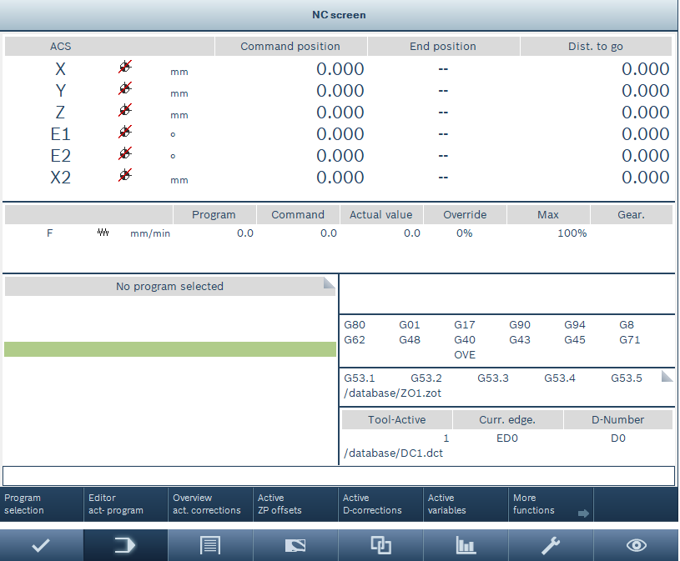

Picture20-13: Change to the preparation context, temperature controller

- Open the screen for TempControl

Picture20-14: Change to the temperature controller screen
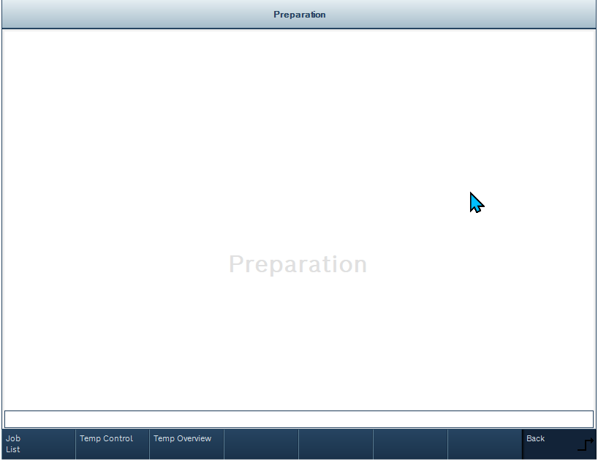

Screen for the TempControl

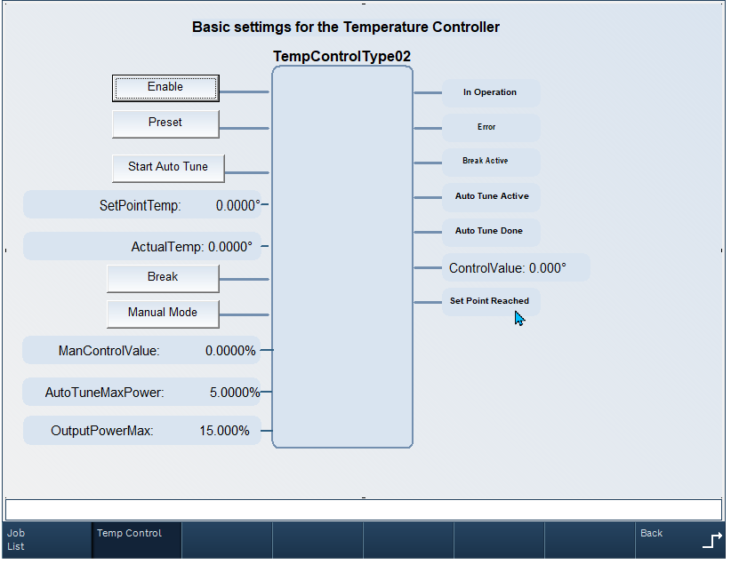

Control elements

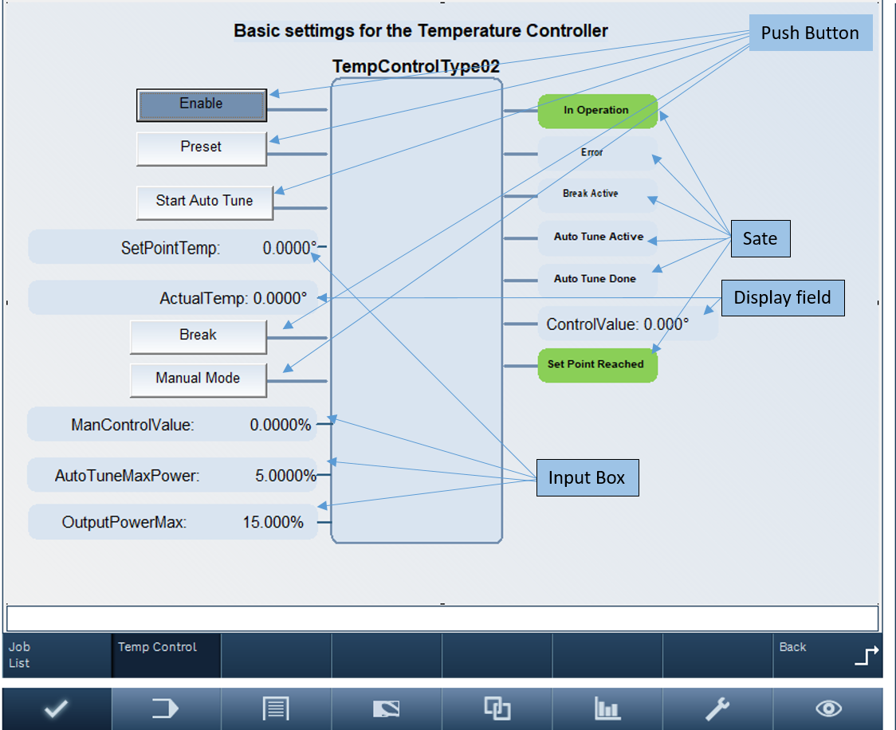

20.7.3 Temperature Overview Screen

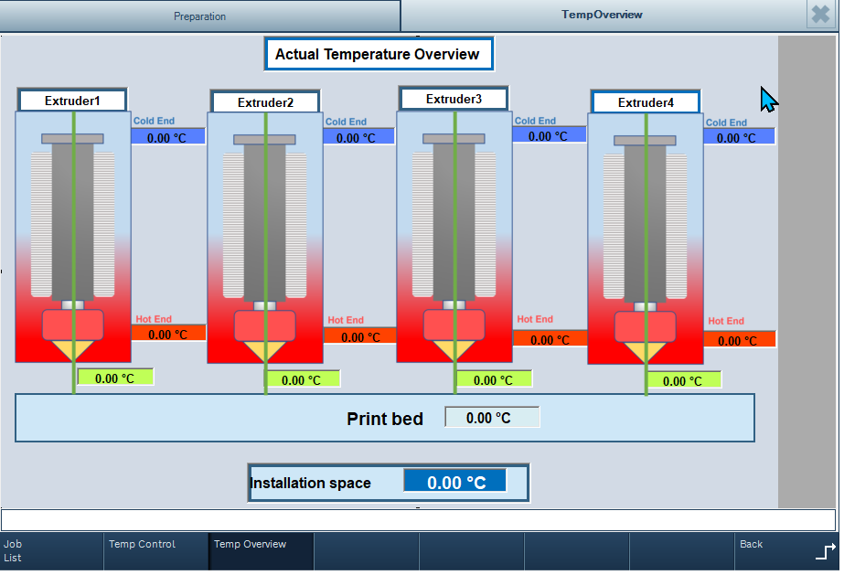

20.7.4 Temperature Overview Control in the NC-Screen

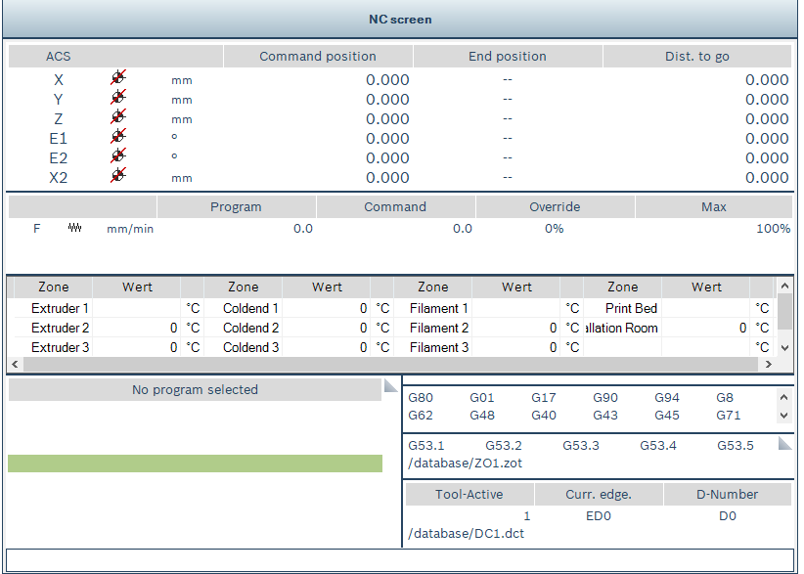

20.8 NC Simulation

In the project, a machine model, of a 3D printer, is implemented. This machine model can be started with the NC simulation. A detailed description of the NC simulation can be found in the documentation R911399601 "NC Simulation Multitouch".

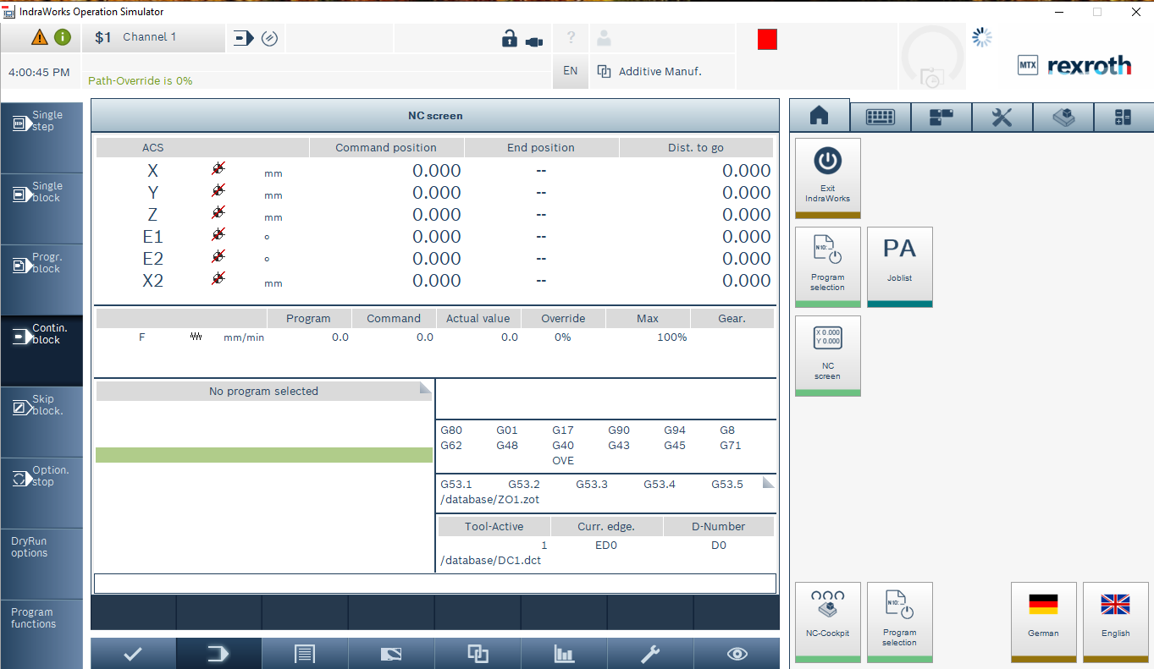
Picture20-13: NC- Cockpit

The machine model can be started with the NC cockpit button on the HMI. The NC simulation is optional and not included in the basic package.

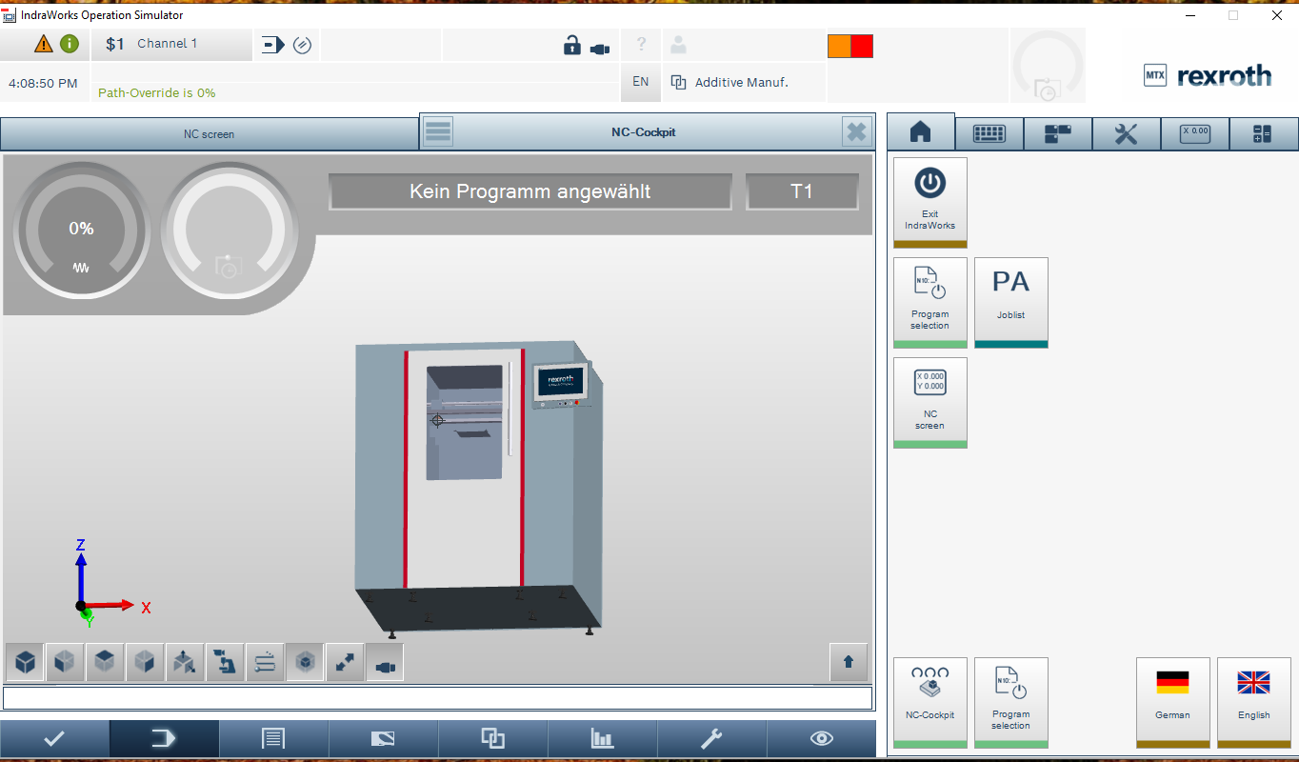

Picture20-14: Machine Model

