- I/O engineer add 8 drives （Moon’s）。
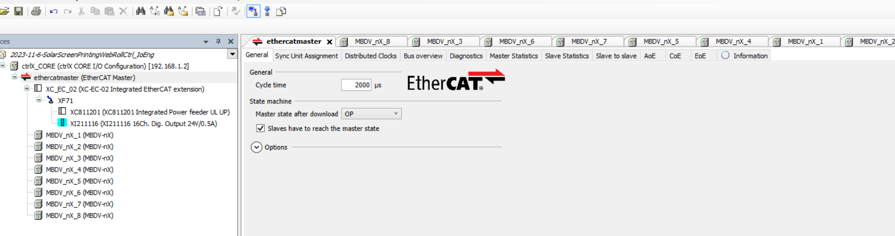
- The same PDO
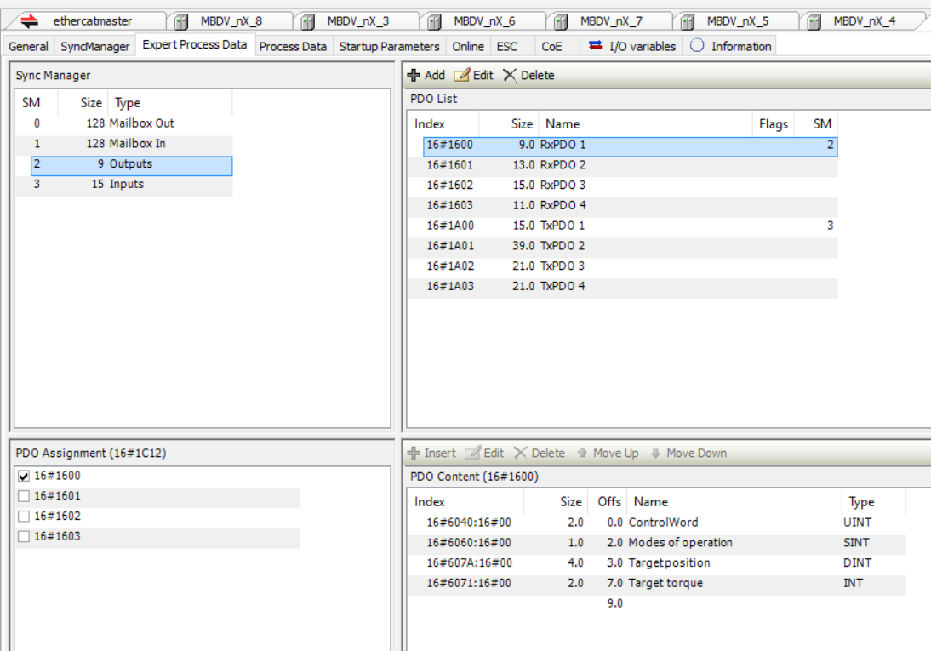
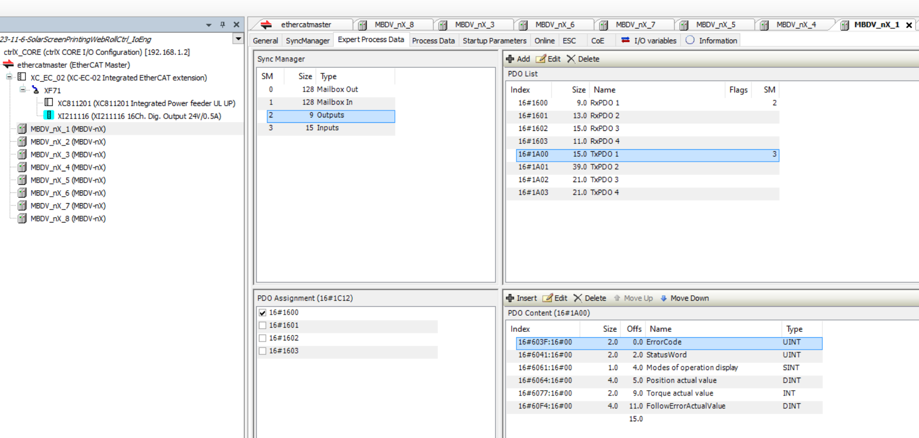
- Device online and download, all motor data is ok.

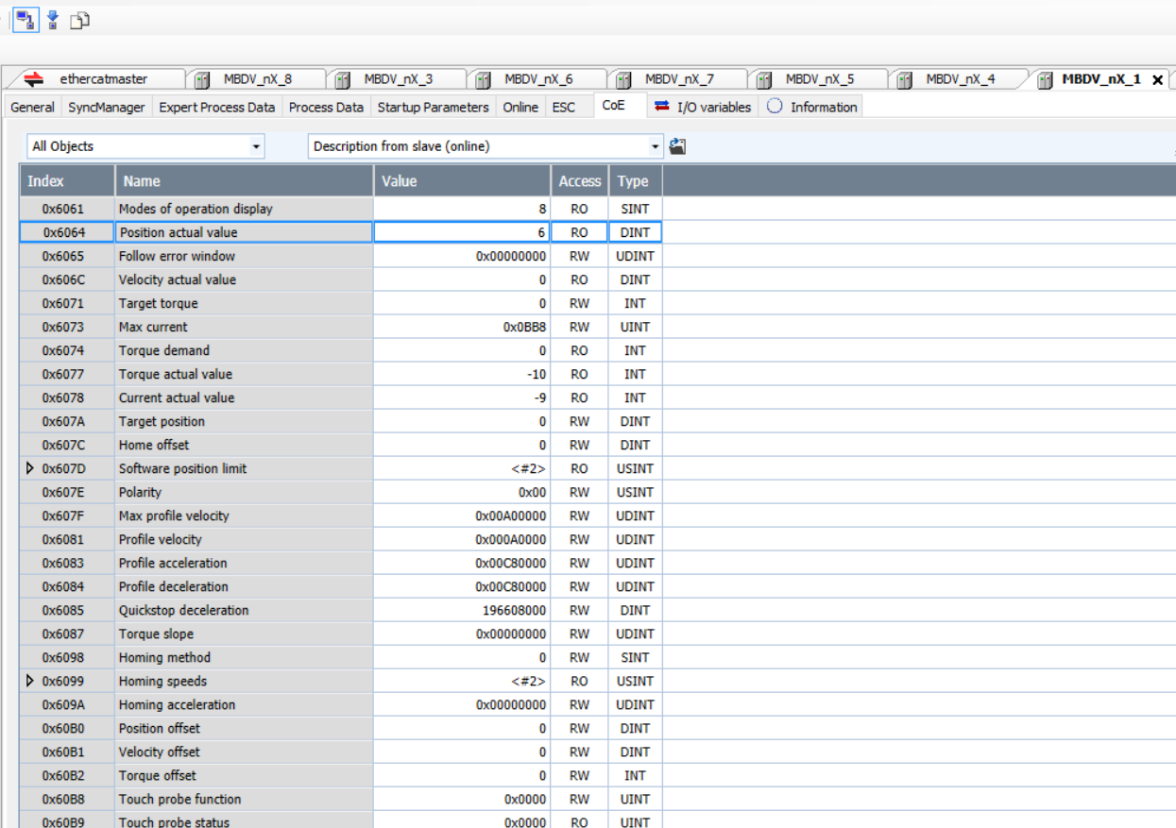

Ethercatmaster no error
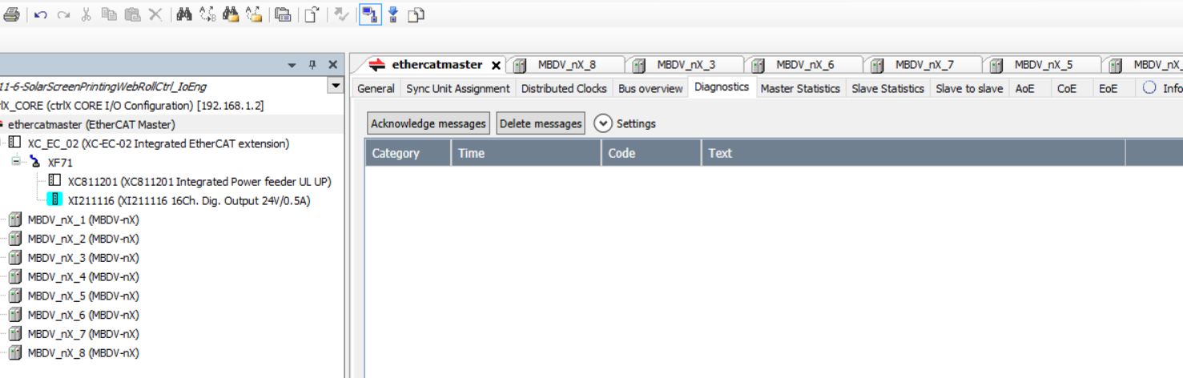
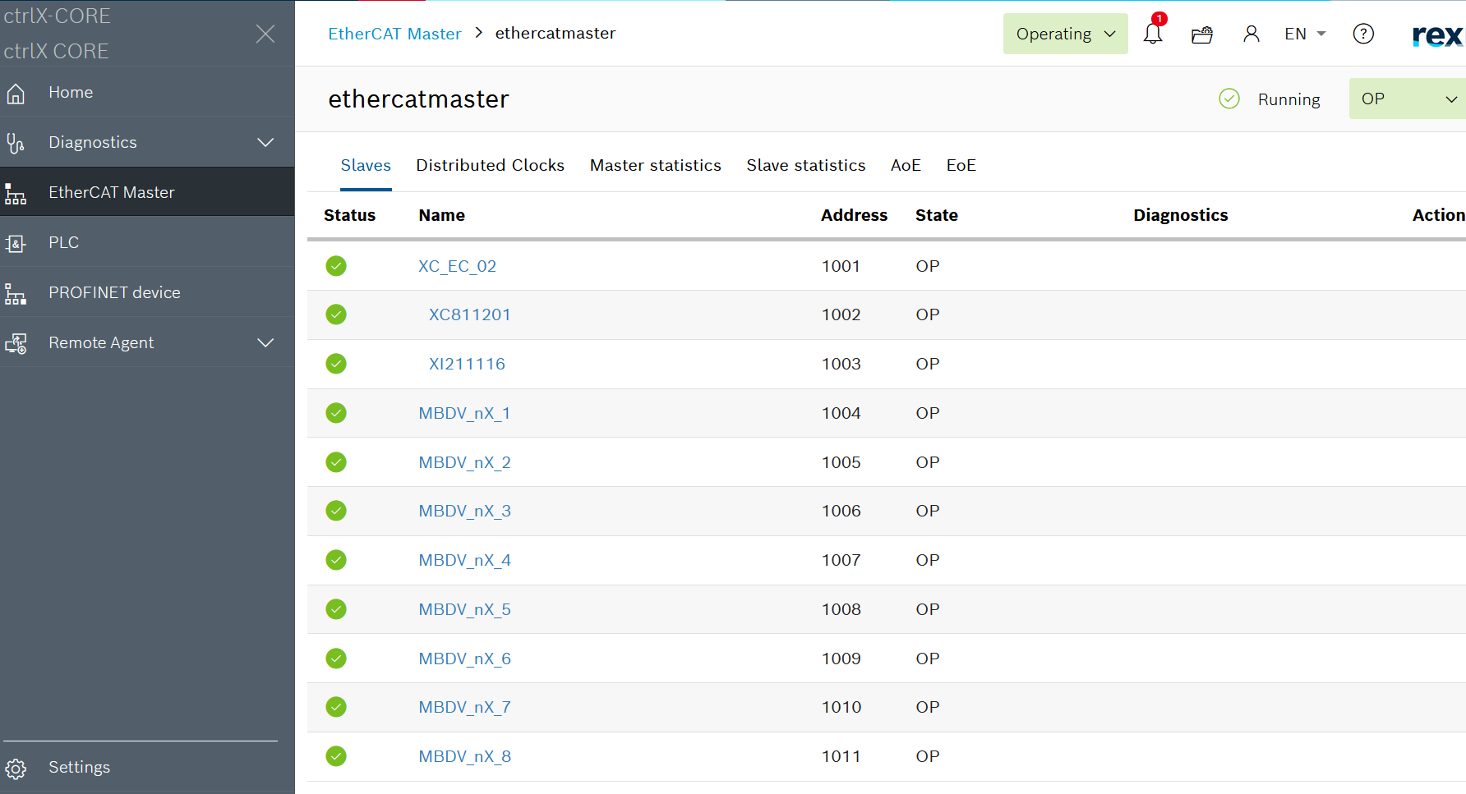

- plc engineer add “SoftMotion COE Axis”

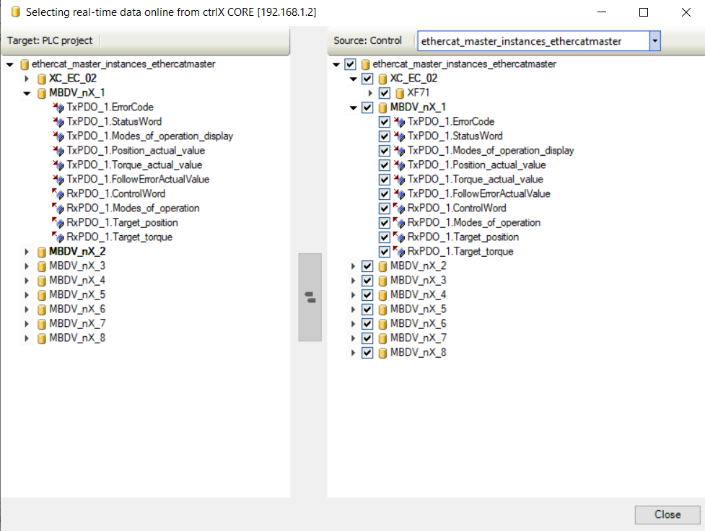
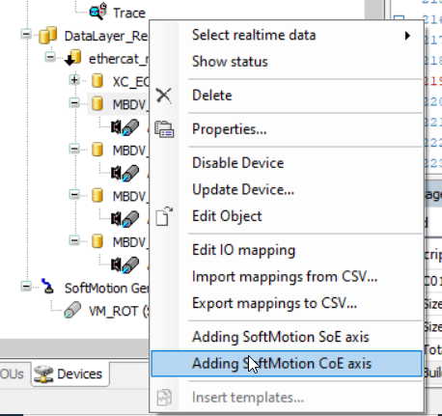
5 .Plc program login, no error.
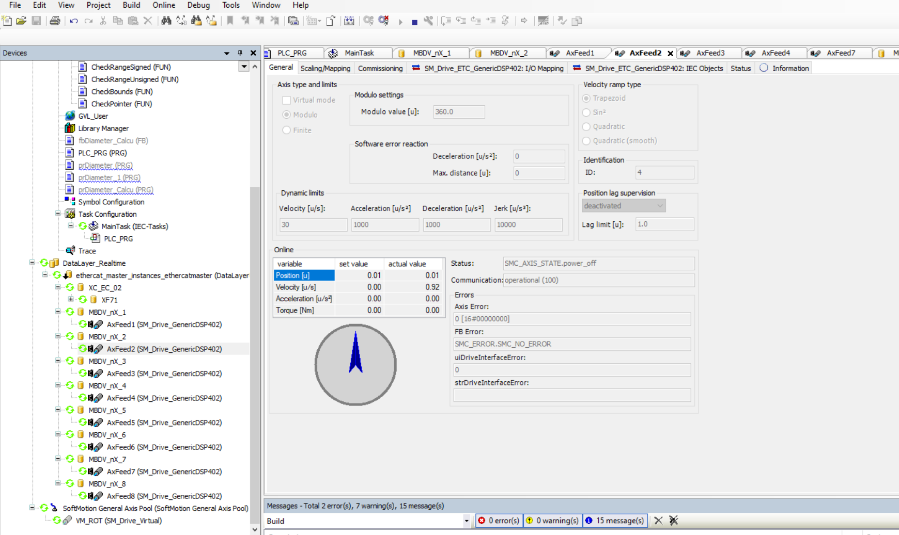

6. About 2 minutes later
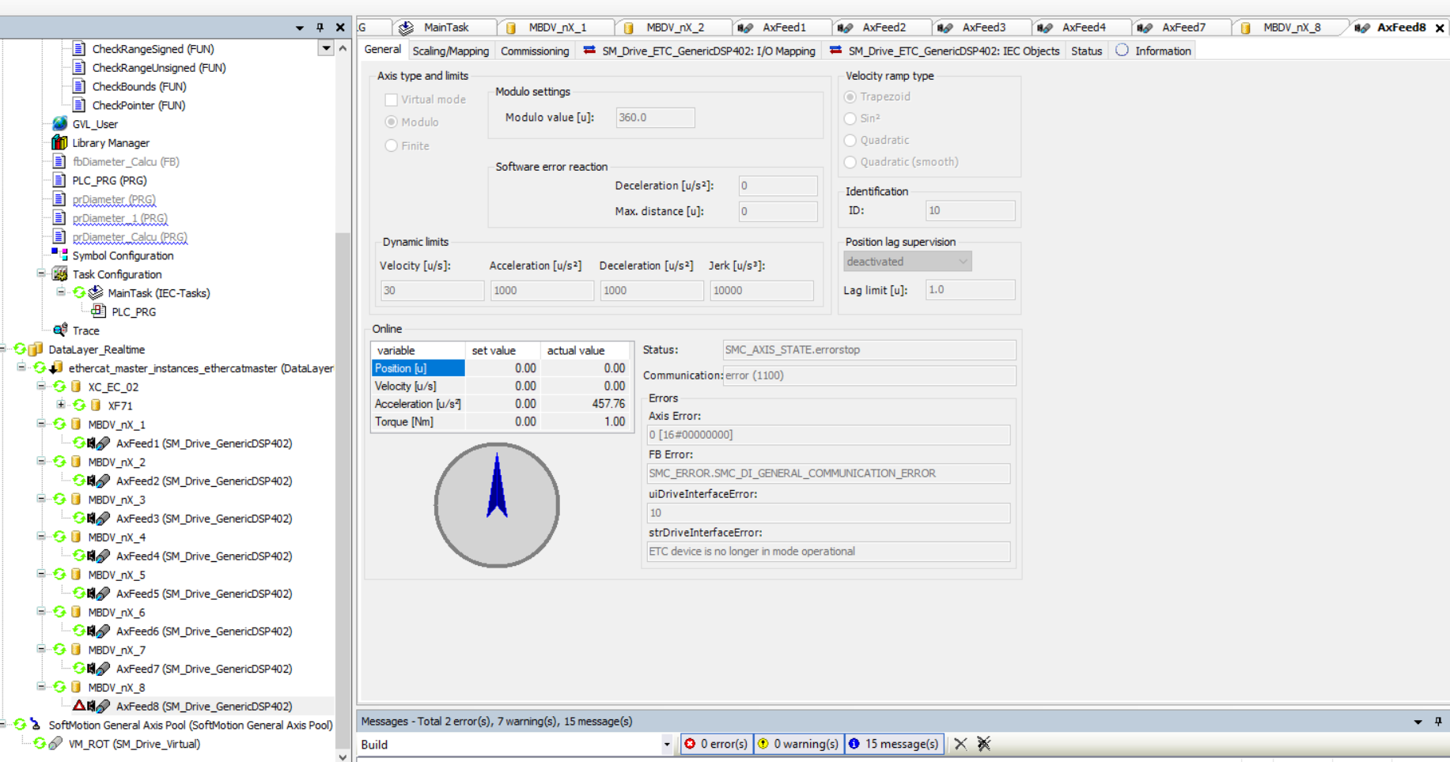
About 1 minutes later
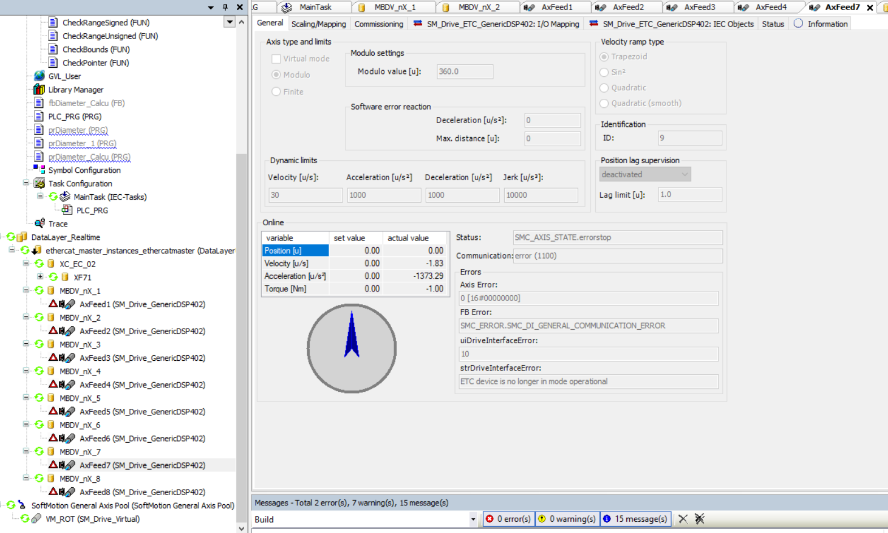
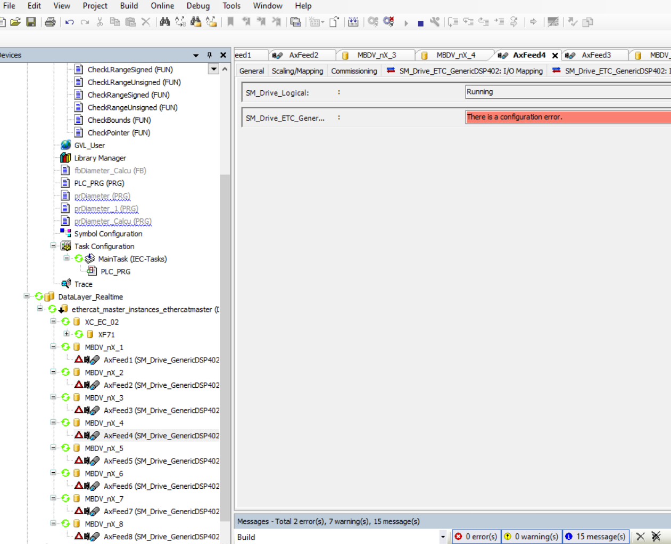
I/O Engineer
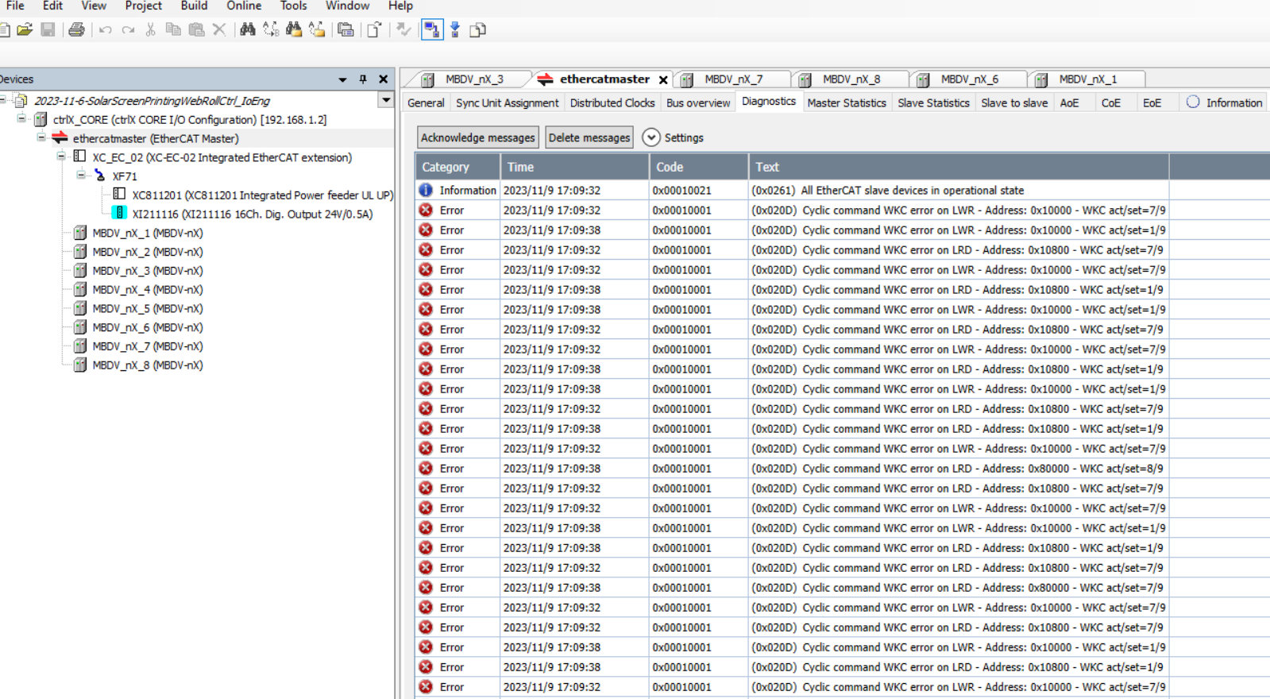

Web status ,slaves(random) state OP-Init-OP
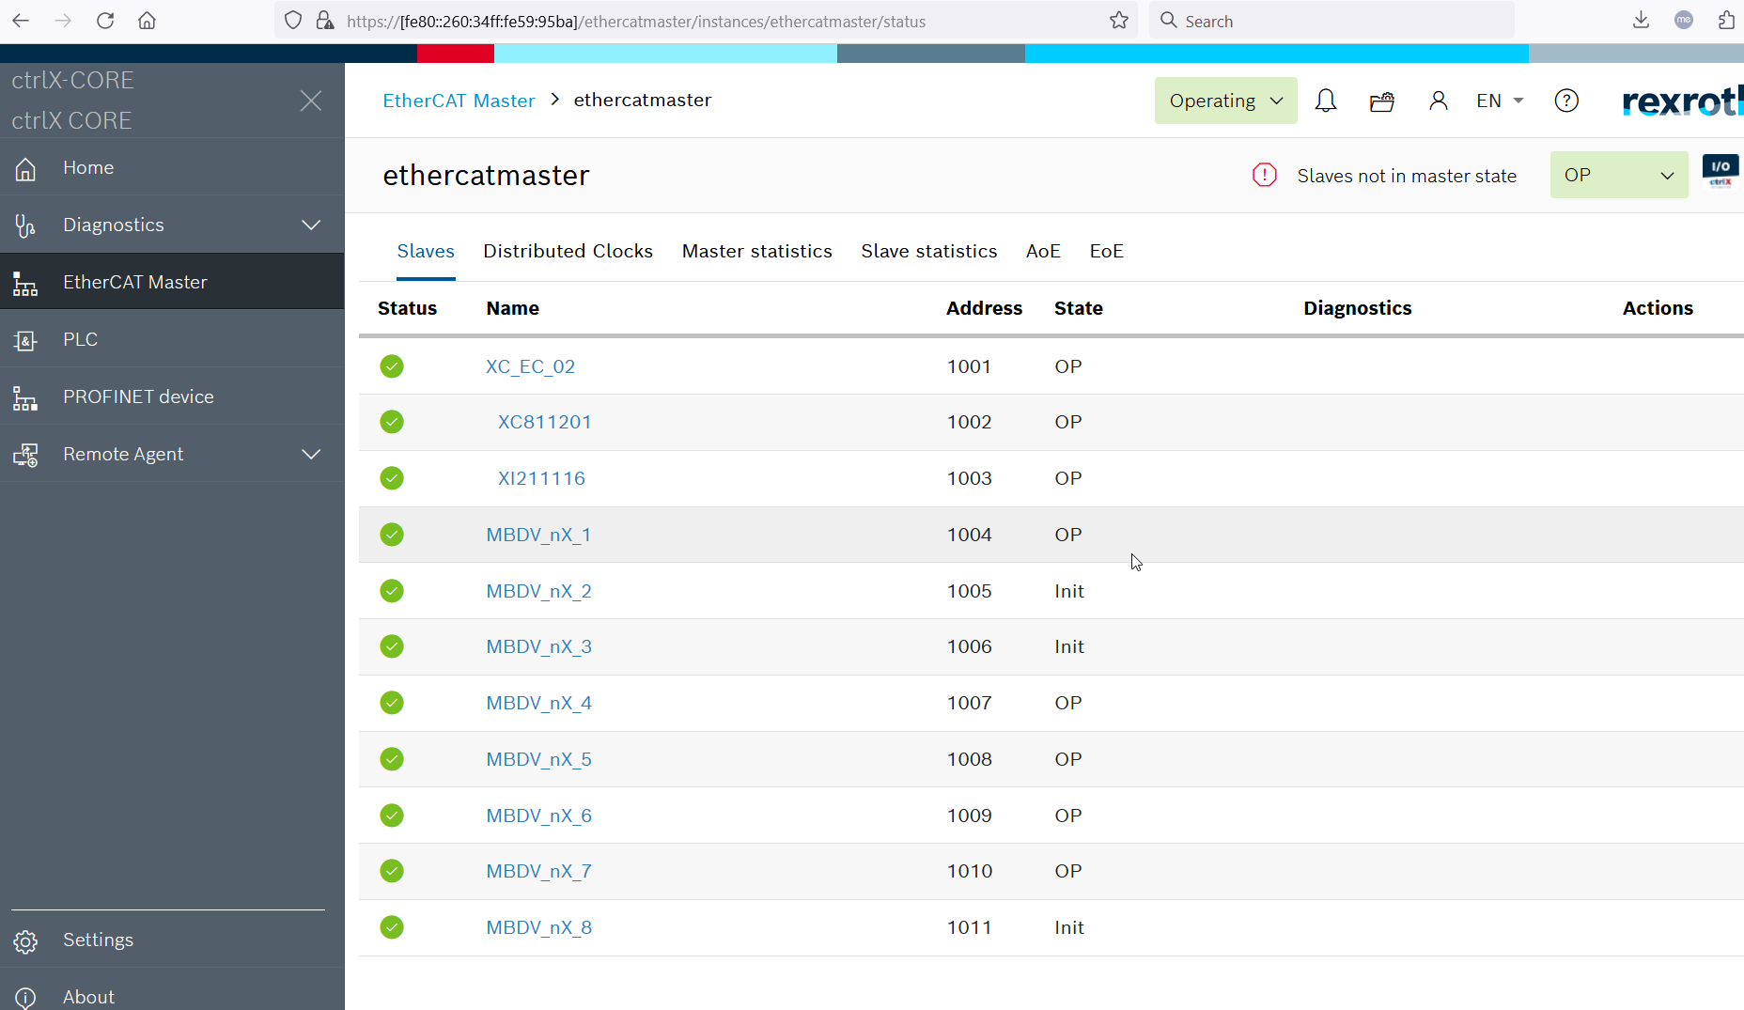

When the core is running, the EtherCat Master is lost.
This error appears 2-3 times.
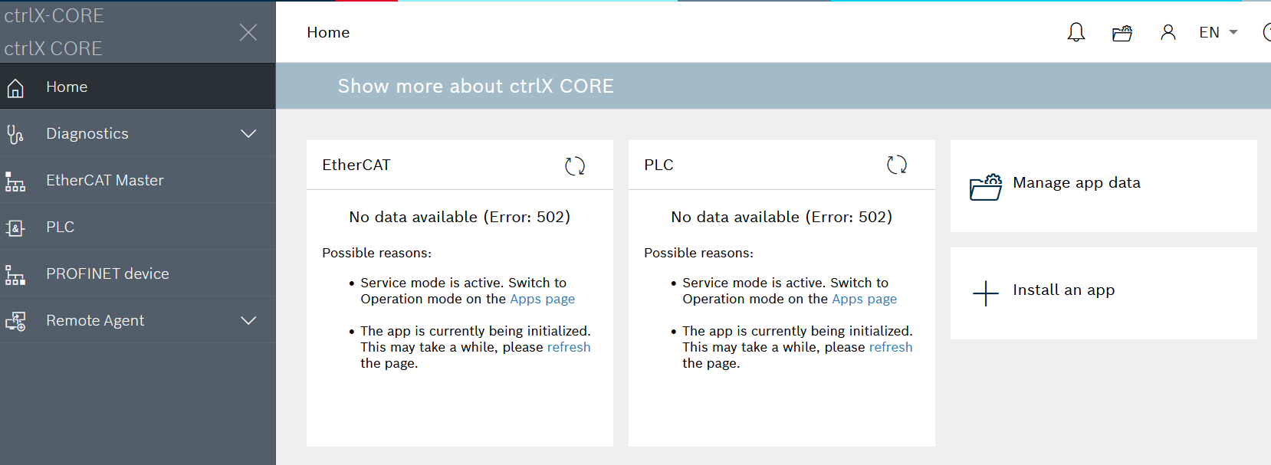

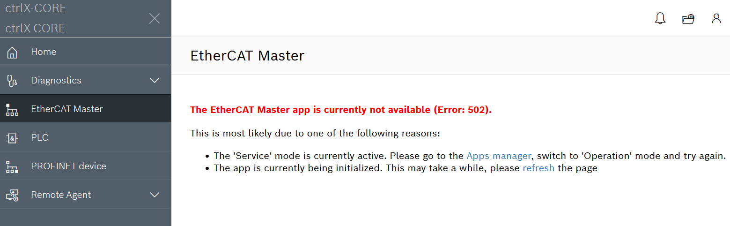

The control from “Operation mode” to “Service mode”
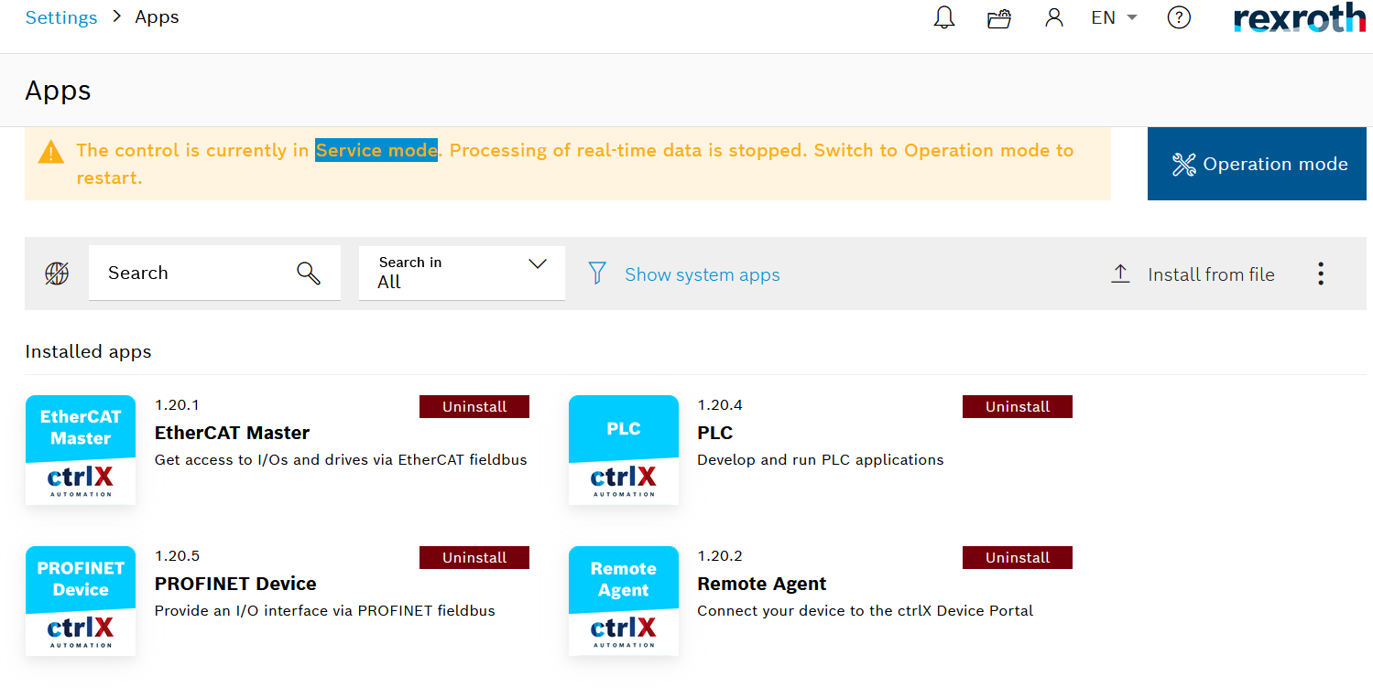

Select  ,
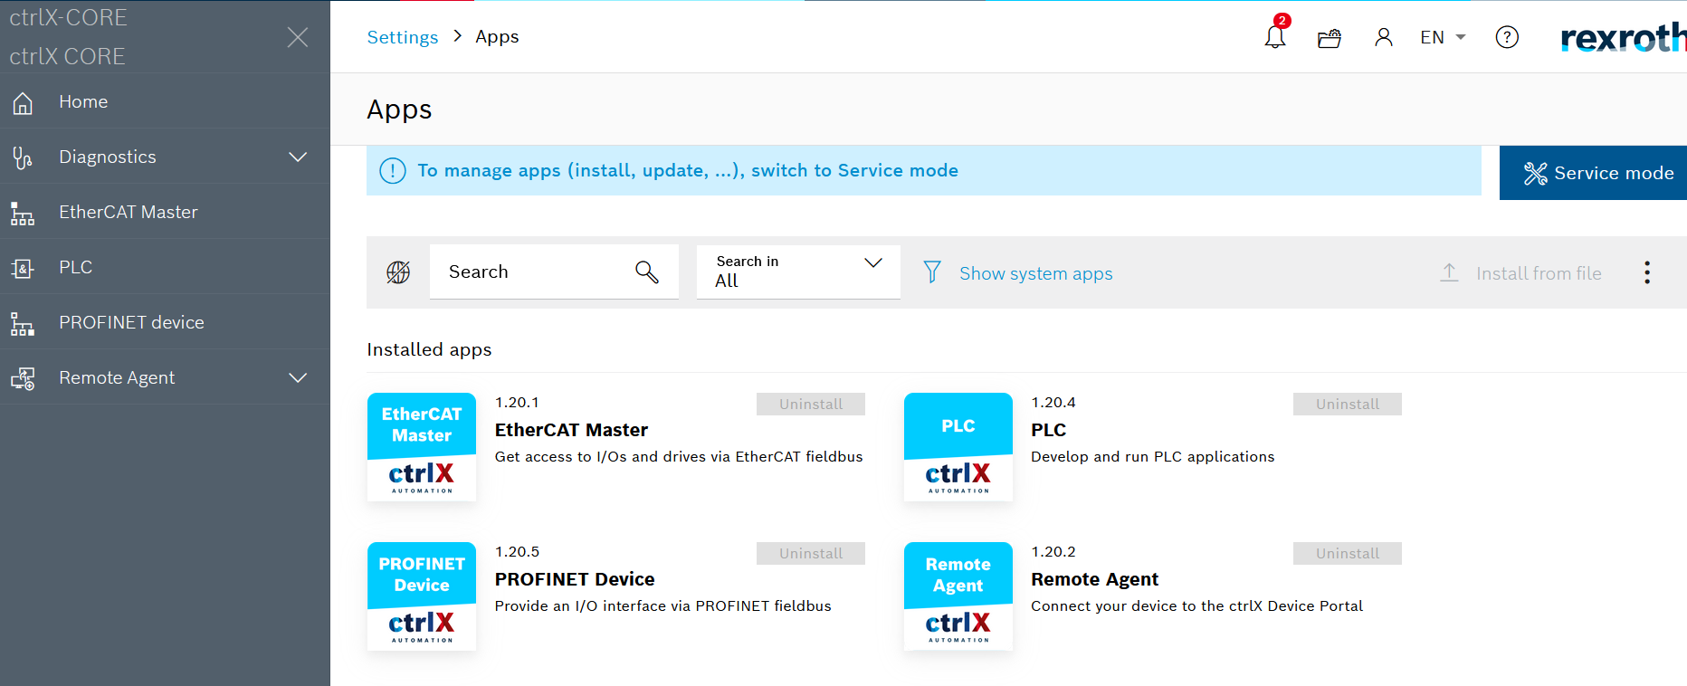

and then select “EtherCat Master”
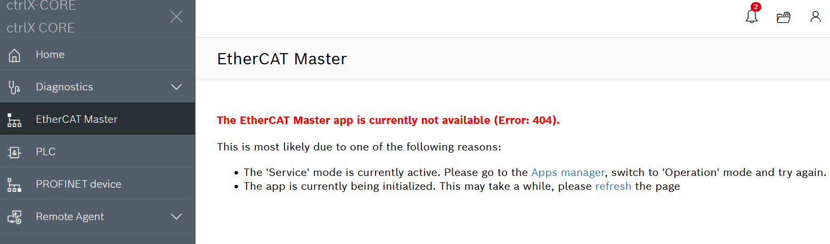

Select “Refresh ”
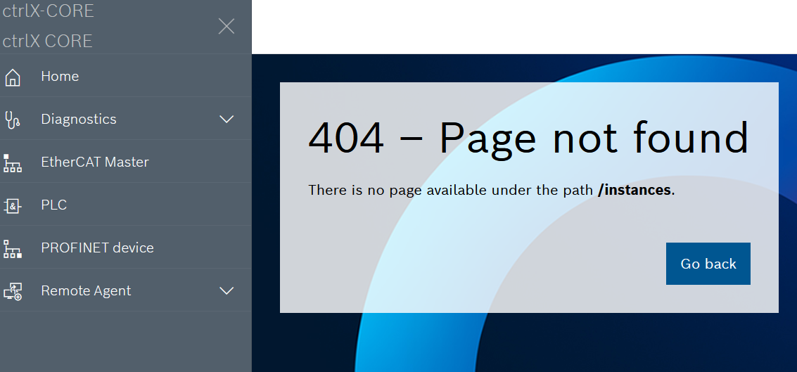

Power off and on , the system is ok.

Please check the system report and backup file.

