

How to commission
safe (FSoE) ctrlX DRIVE
under EtherCAT control
Version 01

Content
1. General information 3
2. FSoE Settings 5
2.1. EtherCAT (TwinCat3) drive implementation 5
2.2. Task settings 6
2.3. Safety Settings of TwinCAT 7
2.4. Safety Settings of ctrlX DRIVE 10
2.5. Test of State Machine 11

1. General information
In the following we show to you how you commission a Fail Safe over EtherCAT (FSoE) ctrlX DRIVE under an EtherCAT (in here TwinCAT 3) control.
Topology
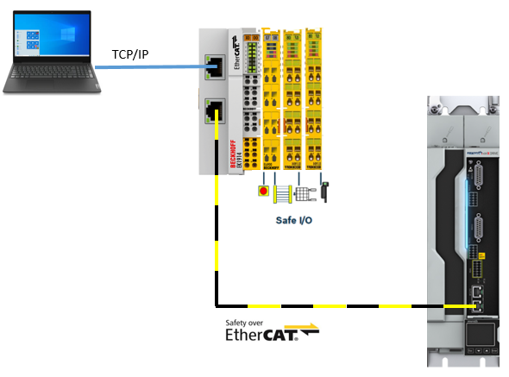
Fig. 1: Topology

All the functions and screen shots are based on:
Versions used
- ctrlX DRIVE Engineering version >= 01V14
- ctrlX DRIVE firmware/runtime version >= AXS-T-0305
- TwinCAT 3

The Beckhoff TwinCAT system and ctrlX DRIVE Engineering have been successfully installed on your PC and started.
Prerequisites

The ctrlX DRIVE and EtherCAT components used for this document are:
Used hardware
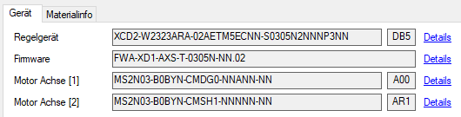
Fig. 2: ctrlX DRIVE components used
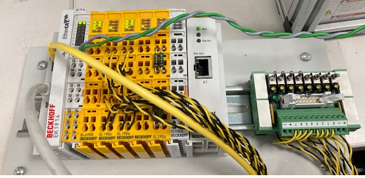
Fig. 3: Beckhoff EtherCAT components used
In particular the following units were used:
- Beckhoff EtherCAT coupler EK1914
- Beckhoff EtherCAT communication interface EL6900
- 2x Beckhoff EtherCAT 4-channel digital inputs

2. FSoE Settings

2.1. EtherCAT (TwinCat3) drive implementation
Start NC default project and add EtherCAT Master!
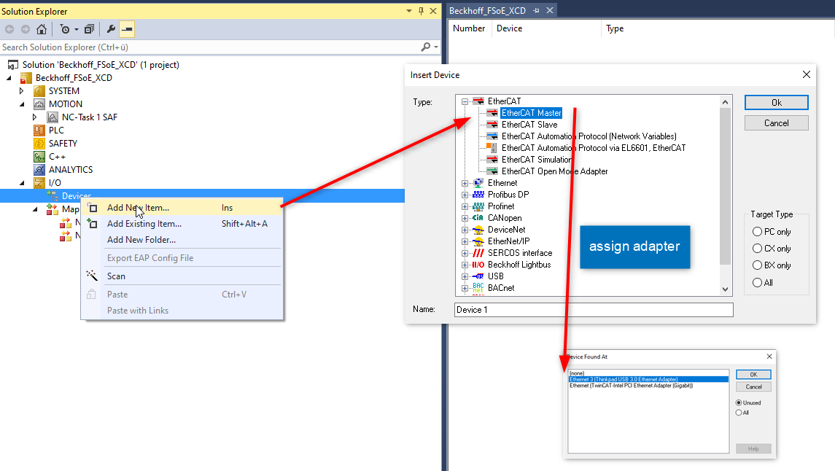
Fig. 4: Add EtherCAT master
Add your drives via Scan or manually!
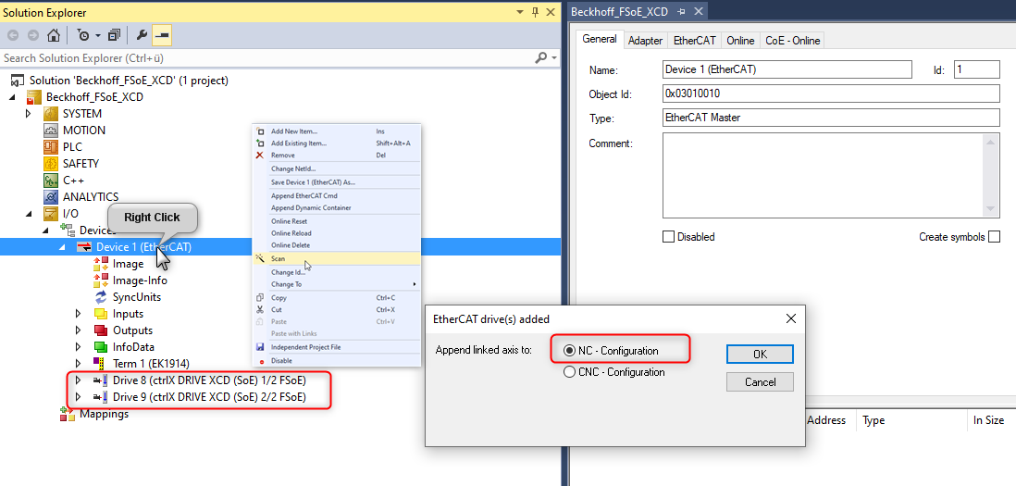
Fig. 5: Add connected drives via Scan
Set Engineering over EtherCAT (EoE) settings and activate configuration!
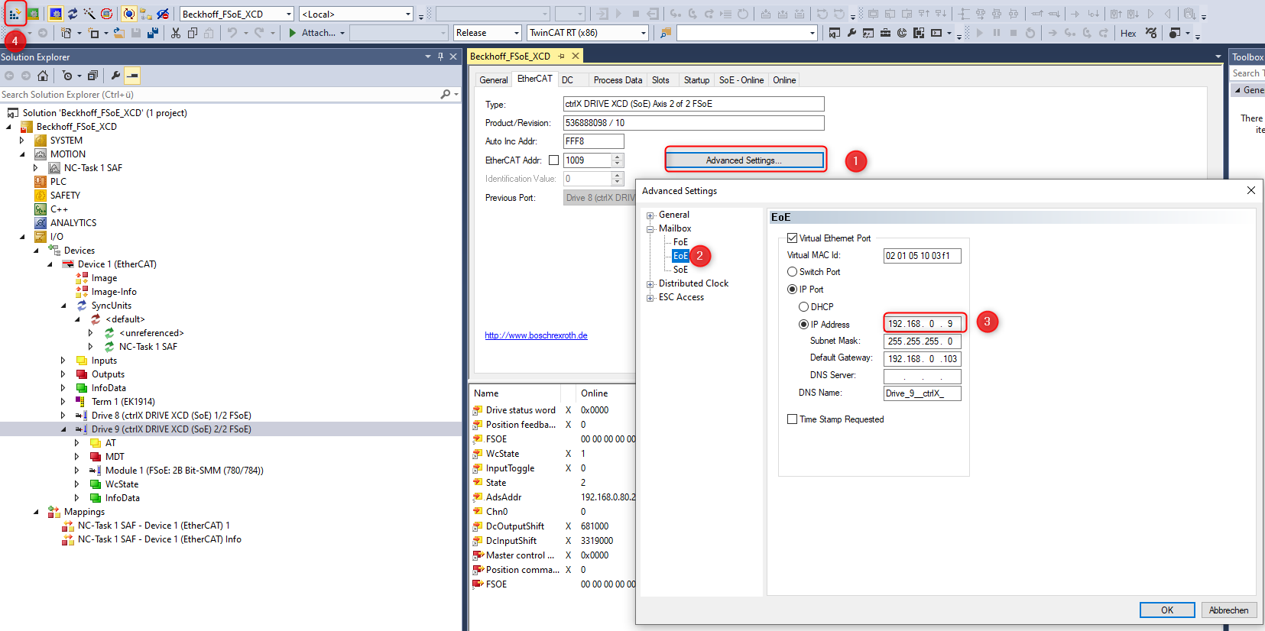
Fig. 6: Set EoE settings
After activation the “Master” should be in RUN mode and drives should be found via EoE connection.
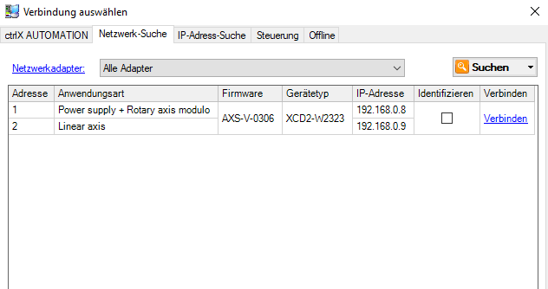
Fig. 7: ctrlX DRIVE connected found over EoE connection

2.2. Task settings
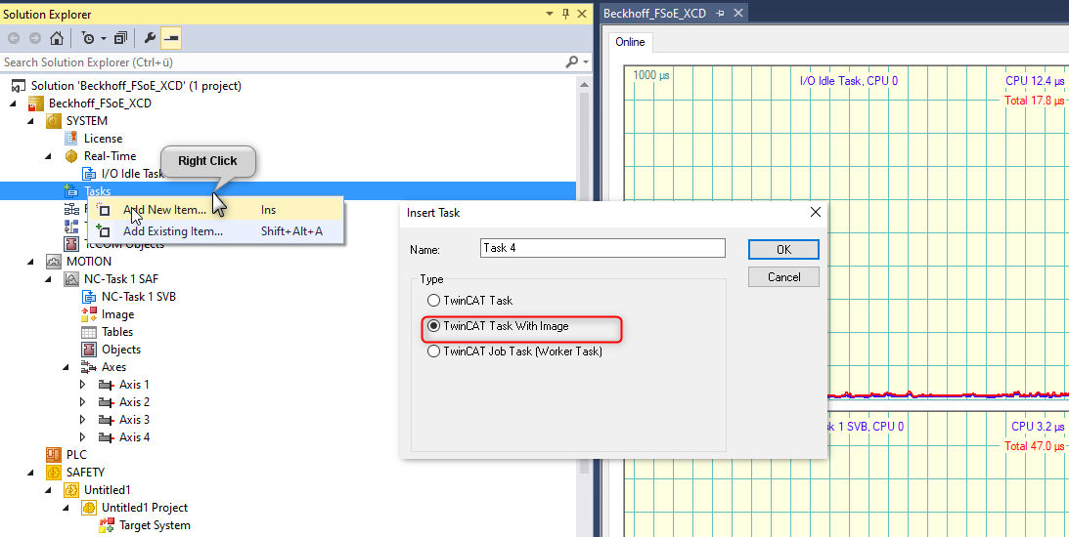
Fig. 8: Task settings
Add two Variables for Error acknowledging (ErrAck) and for distinguishing “Run” and “Stop” condition (Run_Stop)!
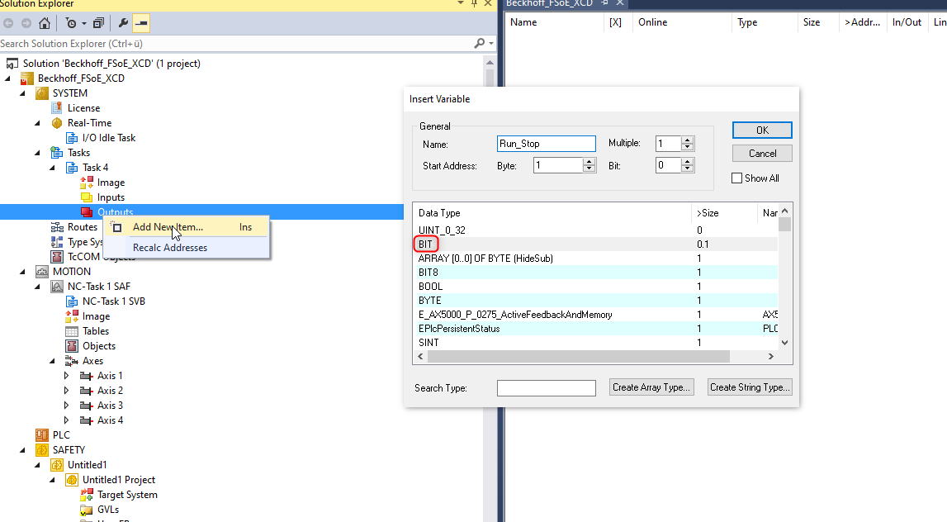
Fig. 9: Add variables ErrAck and Run_Stop

2.3. Safety Settings of TwinCAT
Add new SAFETY item!
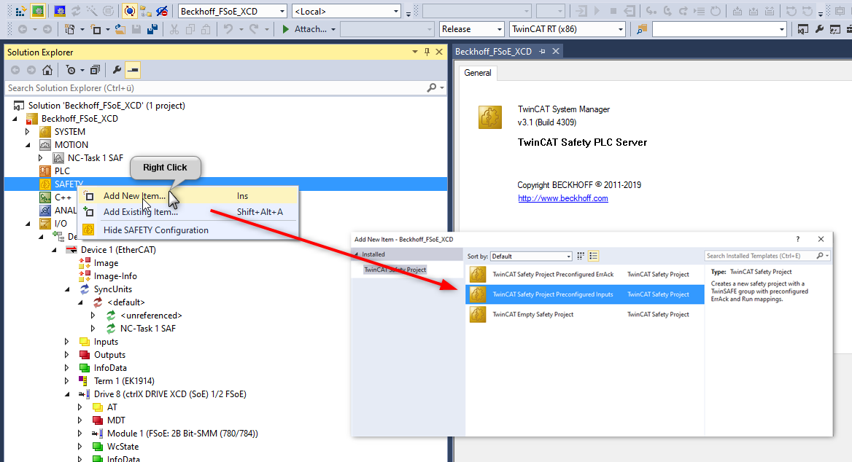
Fig. 10: Add new safety item
Select used devices in the project (can also be deleted later). Otherwise a compile error occurs.
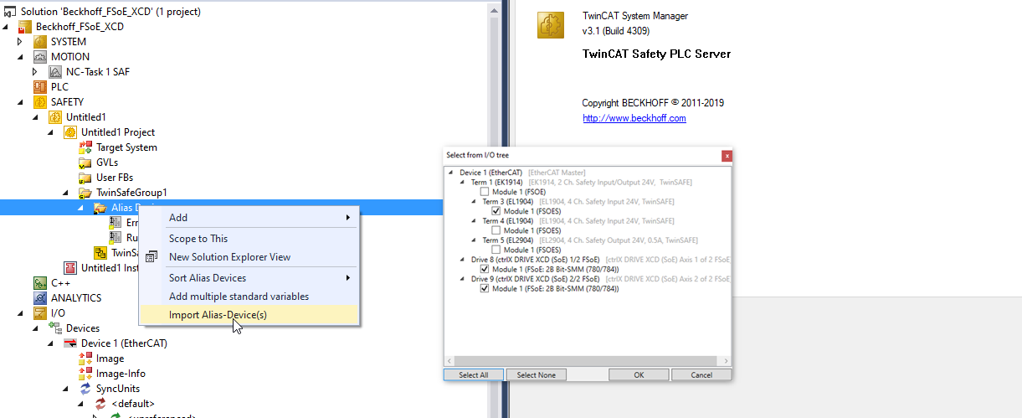
Fig. 11: Select used devices
Set the FSoE addresses (same as drive settings)!
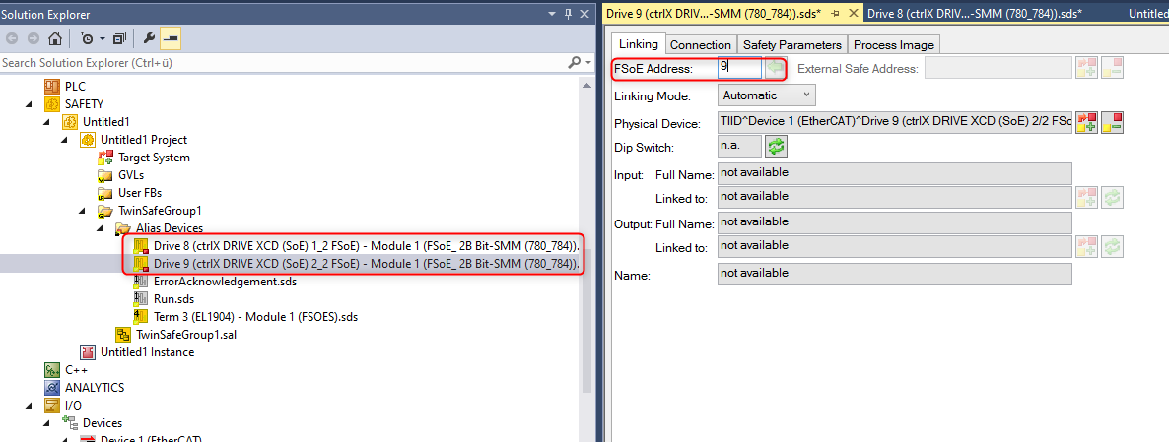
Fig. 12: Set FSoE addresses
Set the FSoE adresses of the used so called “Terms”!
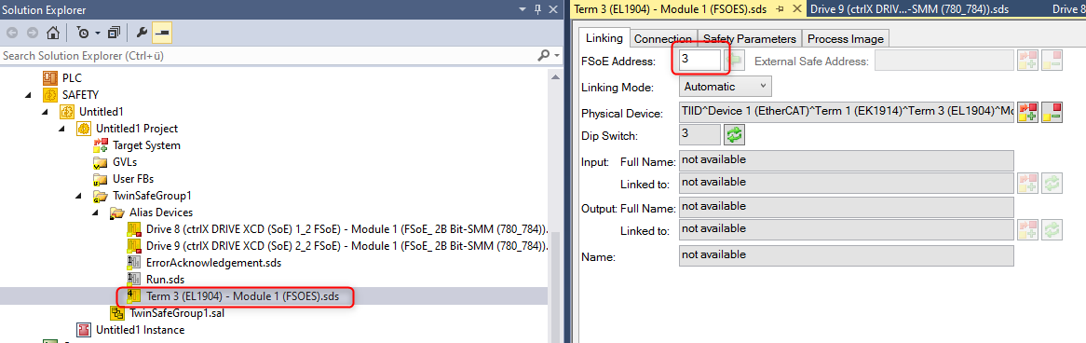
Fig. 13: Set FSoE adresses of used Terms
Add function block e.g. safe decouple to Network.
ErrAck and Run_Stop get linked automatically.
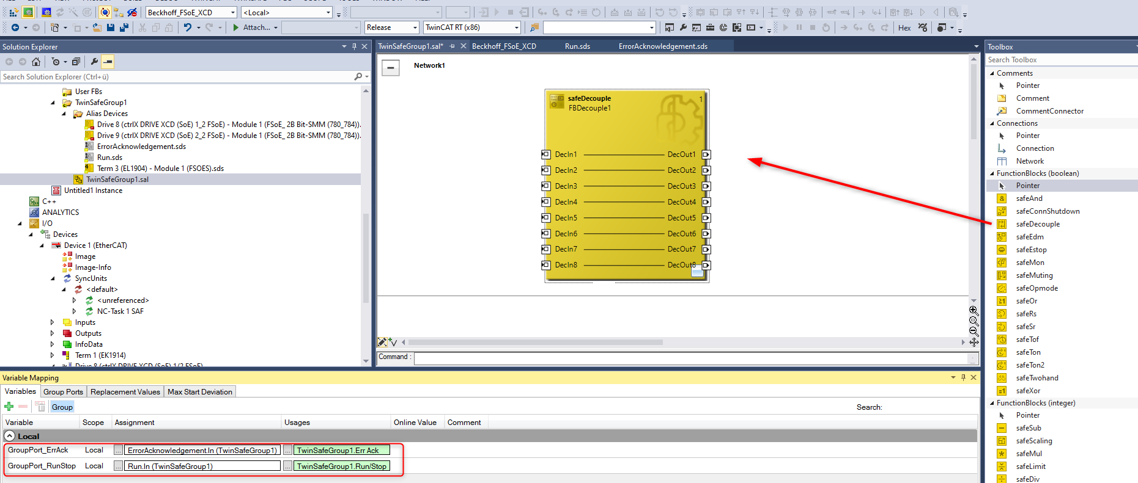
Fig. 14: Add safe function block to Network
Create your inputs and assign them!
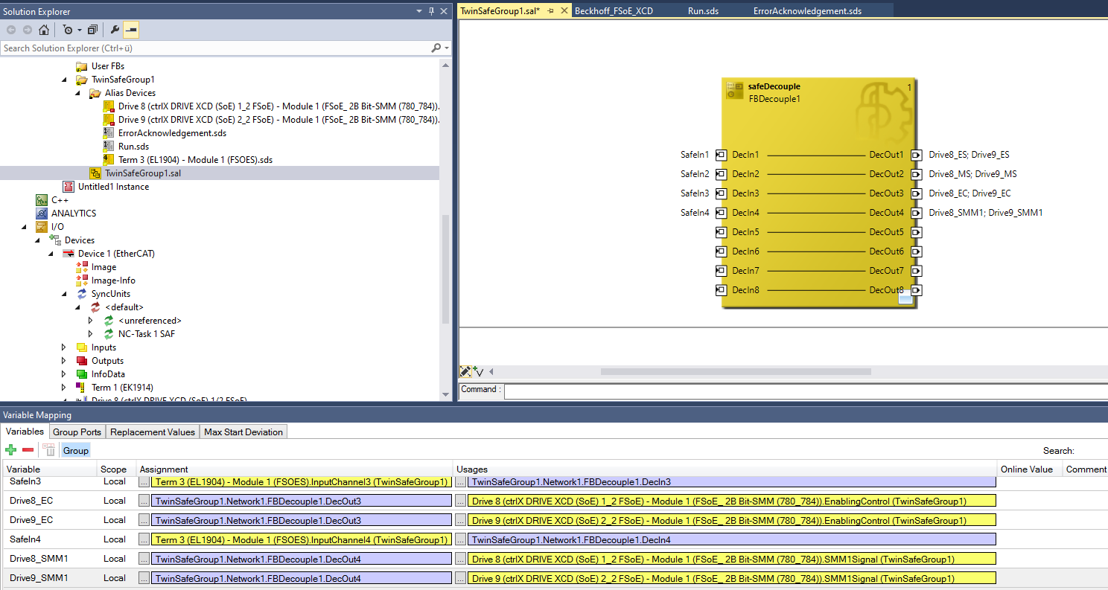
Fig. 15: Assign inputs
Link Run_Stop/ErrAck to Variables!
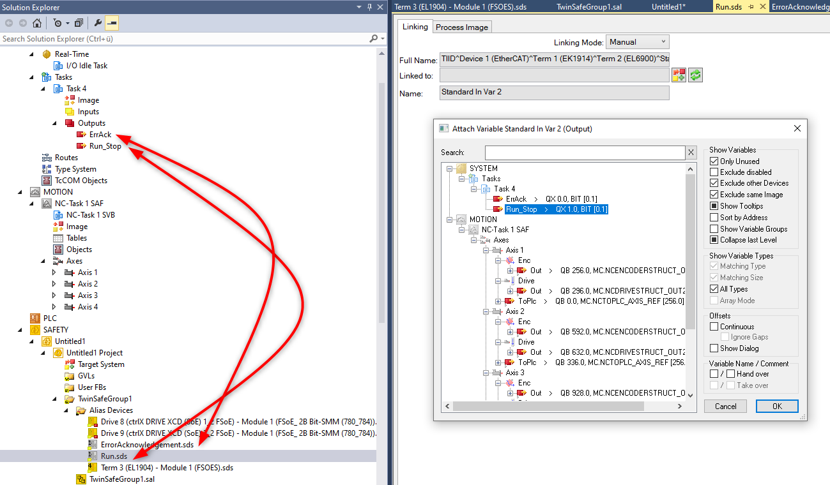
Fig. 16: Link variables ErrAck and Run_Stop
Choose your target system and adjust the Safe Address!
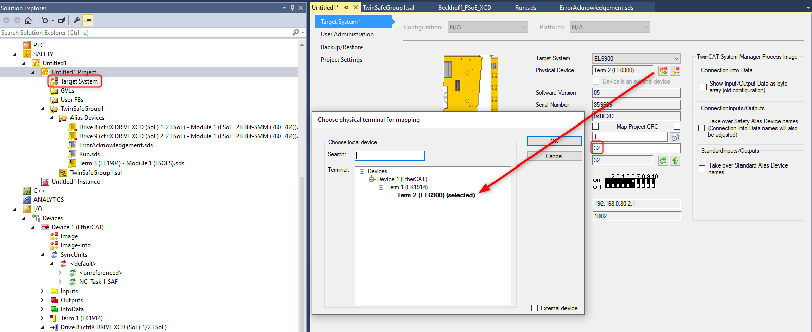
Fig. 17: Choose target system and adjust safe address
Password must be entered again.
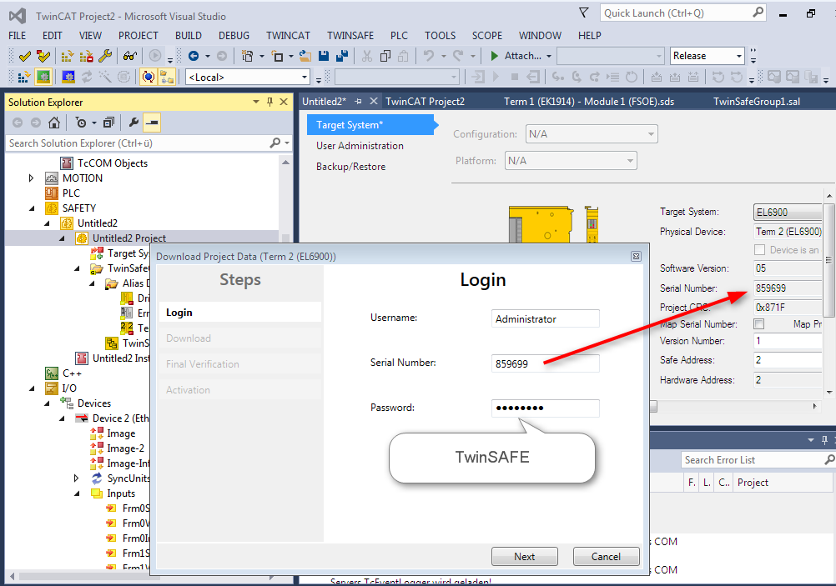
Fig. 18: Login via Password
If Verification works without error Download the project!
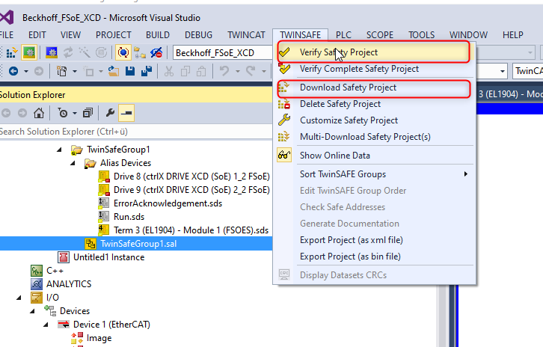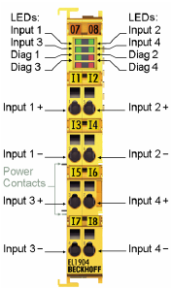
Fig. 19: Verify and download safety project
After project download LED Diag 4 blinks -> Force ErrAck, LED Diag 4 should now light up permanently.
Force output Run_Stop as well!
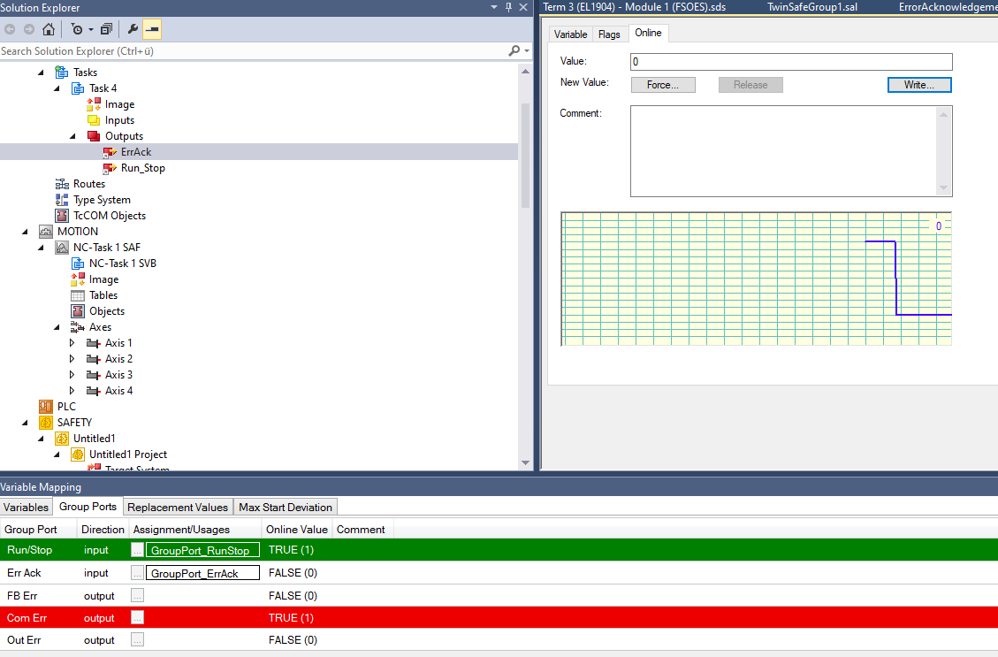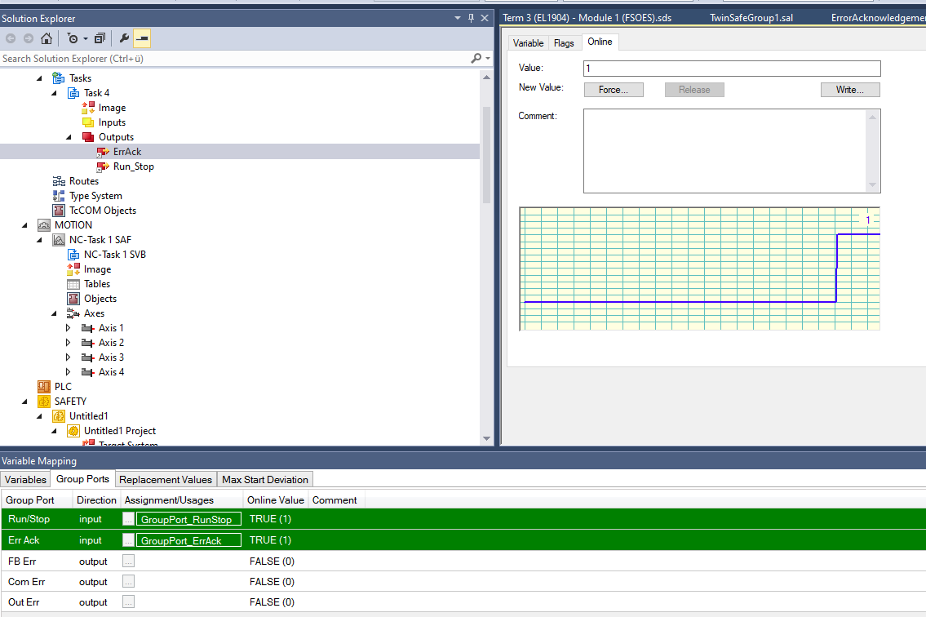
Fig. 20: Force Run_Stop and ErrAck

2.4. Safety Settings of ctrlX DRIVE
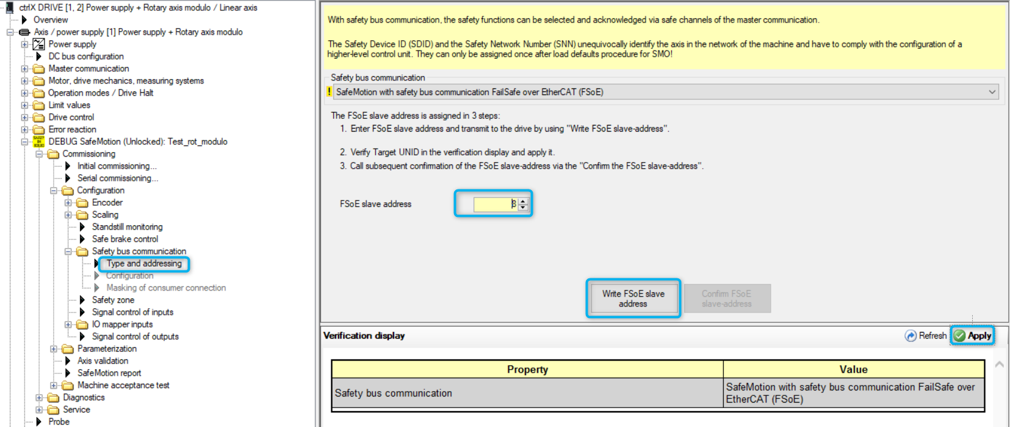
Fig. 21: Set Safety bus communication and FSoE slave address
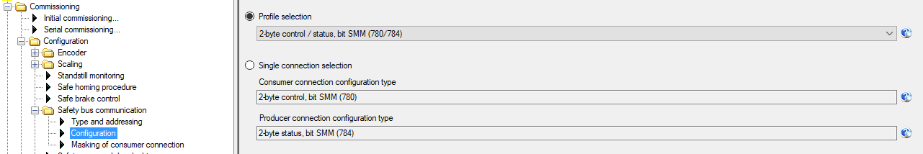
Fig. 22: Configure profile

2.5. Test of State Machine
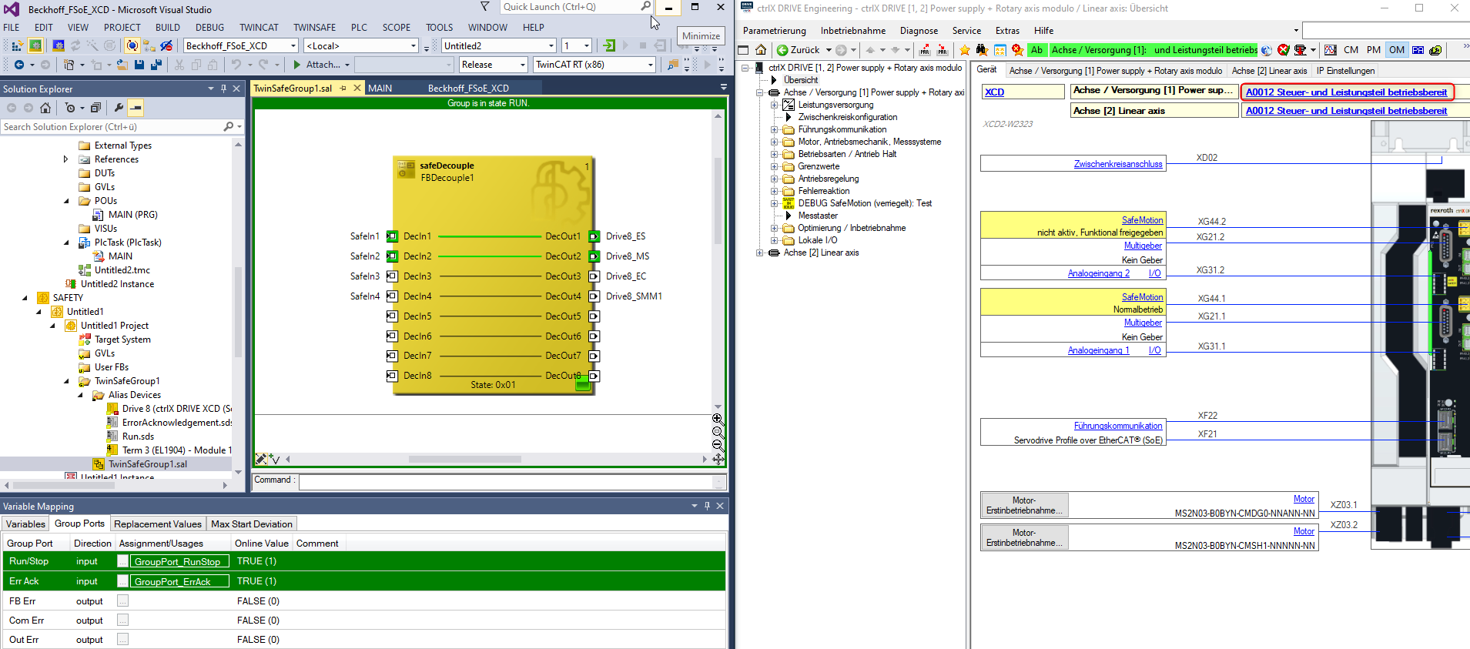
Fig. 23: Test normal Operation Mode
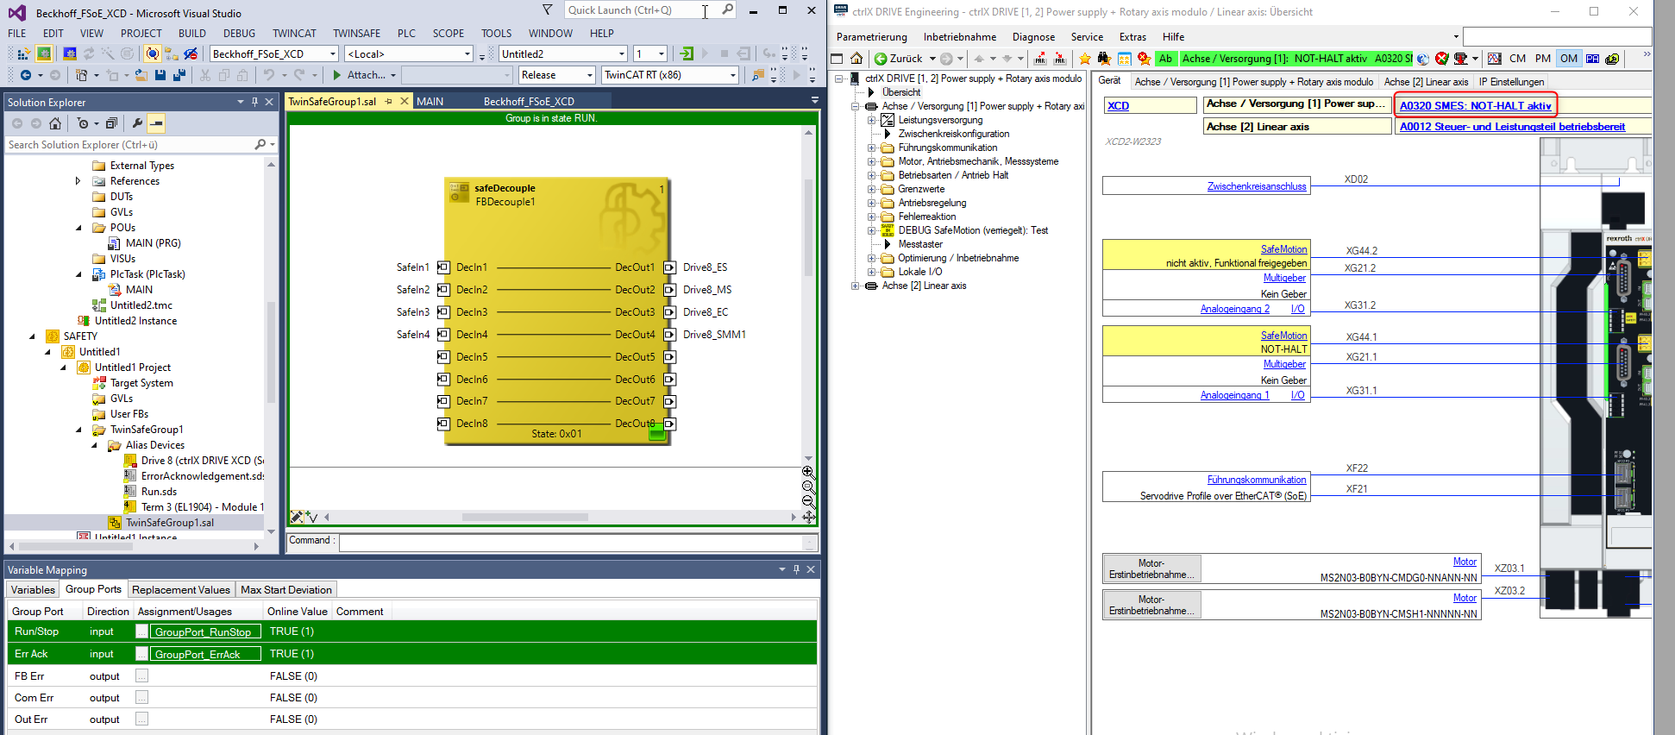
Fig. 24: Test Safe Emergency Stop (SMES)
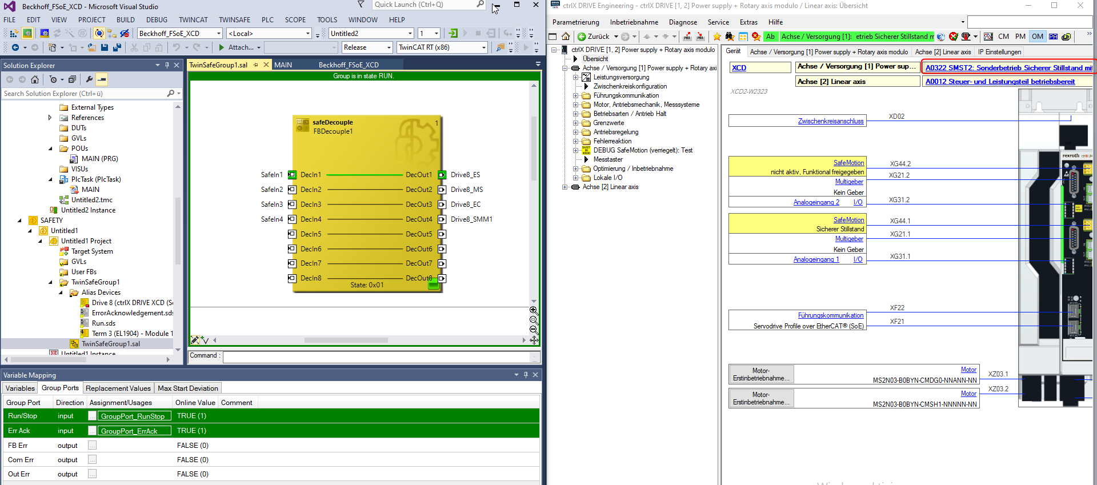
Fig. 25: Test Safe Operational Stop (SMST2)
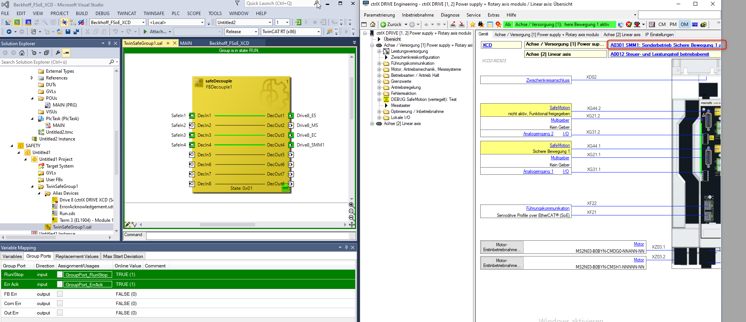
Fig. 26: Test Safe Motion (SMM1)

